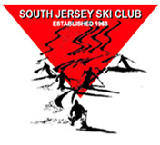
Fashion Show by D&Q
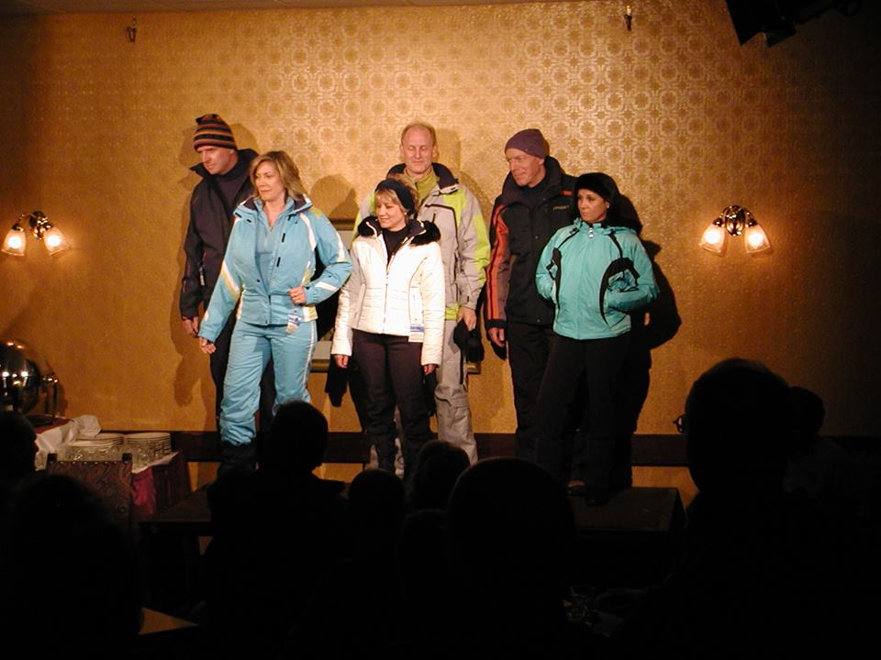

Wednesday, November 11, 2015
7:30 pm during the SJSC November meeting held at
Ramblewood Country Club in Mt Laurel

Back this year is the fashion show presented by

If you would like to see the latest inovation in ski or
Snowboard fashion - THIS is the place to be.

Volunteer models needed - 3 females & 3 males,
Contact Paul Serdiuk at pis9@yahoo.com

