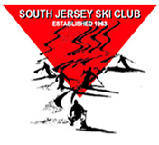
Happy Hour at
‘the Blue monkey’

Friday, November 13, 2015
40 Select Beers on Tap

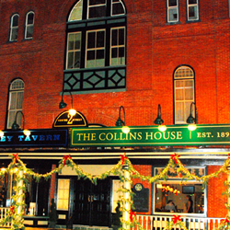

2 South Centre Street
Merchantville, NJ
856.661.8008
Daily specialty drinks & appetizers
http://bluemonkeytavern.com

For more information contact:

Rich Klein at 856.220.0158 or RSK77@comcast.net

