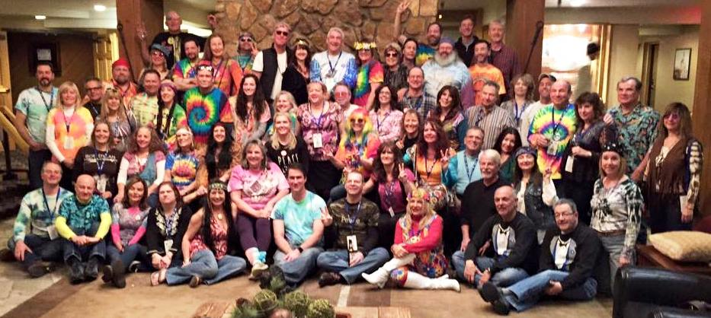

WINTER CARNIVAL: Big Sky Montana 2016
By Terri Corbo

Our day of departure went smoothly as 68 club members arrived in Big Sky Montana for the Eastern Pennsylvania Ski Council’s (EPSC) Winter Carnival! After a quick stop at the grocery/liquor stores in Bozeman, we made our way to the Huntley Lodge in Big Sky where we checked-in, got our lift tickets, and information about the many EPSC Winter Carnival activities planned for the week. Geri, who had led the group earlier from Newark, greeted the Philadelphia folks with the hotel’s cucumber water. Debbie L. and Mary Dx upgraded to the penthouse suite! After we got settled into our rooms, some ventured out to the Snow Bar, an outdoor bar and dance floor made entirely of snow! The DJ was playing techno music and there was an awesome light show. The Snowbar is only available twice a season, so we were lucky to experience this unique event! Many of us made our way to Montana Jacks (that night and many nights) for a beer and a light dinner. Mother Nature welcomed us with snow showers that lasted all night and left the mountain covered in fresh powder!
Every morning we started our day with an incredible buffet breakfast in the Huntley Dining Room that gave us wonderful views of Lone Peak. Breakfast, which is not generally included in Western trips, was one of the benefits of staying in the Huntley Lodge. Pancakes, biscuits w/ gravy, bacon, sausage, scrambles eggs, fruit, yogurt, bagels, omelet and waffle stations, coffee, hot chocolate, and juice – oh my! Most of us did not need to eat lunch because breakfast was so filling. Folks gathered every morning in this magnificent dining room to plan the day ahead and to enjoy the many delicious breakfast items prepared for us. We were glad to hang out with new friends Greg & Robbin, Bob & Annmarie, and Larry & Louise.
Sunday, many folks took a Guided Tour of the Mountain. For many this was the first time to Big Sky and the tour was helpful to navigate the biggest ski area in North America. Big Sky includes an area known as Moonlight Basin. The 90-minute tour started at the base of Big Sky, went over to Moonlight Basin, and then back to Big Sky. It was a great way to learn the lift system and find some awesome trails. The Mountain Guides were available every day and were eager to show us around the mountain all week.
On the Green Trail tour, Dave Hol got to meet the ski patrol and was treated to a sled ride and some oxygen. After some TLC from Terri, he made a full recovery and was back on the slopes the next day!
Monday, everyone enjoyed the mountain. Late Monday afternoon Celeste, Jody, and Mare took the Zipline challenge through Big Sky! Whee! Monday night was the EPSC Welcome Reception – all 315 Winter Carnival participants gathered in the conference center for the opening event! Drink tickets were provided for the bar, hors d’oeuvres were served, and announcements were made for the week’s activities. We greeted friends from the other ski clubs, including Harold who decided to travel with KoP and our friends from FLSC! Later, many watched the latest Warren Miller movie “Chasing Shadows” in the hotel theater.
Tuesday evening was the social highlight of the week, the Gala with a Woodstock theme “Gettin’ High in Big Sky”. We all dressed as hippies, with tie-dye shirts and wigs and gathered for a group picture by Jack in the Sunken Lobby. This took some coordination as we needed to see all 68 faces! We enjoyed a buffet dinner and dancing. A photo booth was also available to those like John S. who enjoyed donning a pink wig and capturing the moment. Sue J and Debbie G dressed as flower children, Terri was sporting a bee-hive hairdo, Sue E had long flowing black hair, Steve N, Chris, and Brian made their own tie dye shirts! Eric was a “rebel without a cause” . . . Bill C. came as himself! Cindy won the “best dressed” costume award -- congratulations! We danced the night away to 60’s music. Marie was the first one the dance floor . . . and the last one standing on the dance floor. Far-flung friends Erica and Don joined us at the Gala.
Every day, a loose group of Steve R., John Mc, John S, Fred Sals, Fred Sie, John P, Tony, Chip, Pam, Rich Kl., Scott, and Lana skied some of the sickest terrain Big Sky had to offer. In fact, the snow snakes stole Lana’s ski in the Snakepit. Another fun memory is when Andrew took a bunch of us to The Bowl for a “warmup” run in a blizzard that Mary Dom will never forget. Bill W. filmed some great runs with FLSC friends. Joe H and Roy experienced some of their most challenging ski terrain. Laura took a reflecting “frozen beard” pic of Bill C’s goggles and posted some great stats on Trace.
On Wednesday, the EPSC organized an inter-club NASTAR race. The SJSC Racing Team of Rich Kr, Gwen, Celeste, Rich R, Scott and John Mc took the Bronze medal in the competition. We were grateful to new friends Larry & Louise, Greg & Robbin, and Ralph & Nancy for helping out with the race. Dave Har and Dan also helped keep up our team spirit for NASTAR. Congratulations and thanks to everyone who participated! Lunch was provided after the race at the Summit Lodge. Hamburgers, hot dogs, chips, cookies, and soda were served.
On Thursday, 32 people snowmobiled through Yellowstone National Park; Steph and four others enjoyed a snow cat tour. Pat B. looked very GQ in his snowmobile suit. We saw bison, bob cat, elk, coyote, and plenty of beautiful scenery including waterfalls, painted pots pools, geysers, and of course Old Faithful!! EPSC hosted a pizza party Thursday night in the Huntley Dining Room.
The fabulous foursome, Claire, Sue B, Debbie D, and Robin had a “girls trip” that they’ll be talking about for a long time! Friday we enjoyed one last day on the mountain (or was it our last day?!). Karen K won “The Amazing Race” by getting out of town before winter storm Jonas hit the east coast. By Friday, we all became aware that our flights home were cancelled because the Philadelphia and Newark airports were closed due to 20+ inches of snow. Joe B. saved the day by finally getting a live airline representative to start to reschedule some of our flights one at a time. 28 flew to Denver on Saturday and made their way home from there. Some of our group stayed in Denver until the Philly airport re-opened. Bob S. enjoyed the night (all night) in Denver’s downtown pedestrian mall, Terri and Dave went to Red Rocks, Bob B. went to Bronco’s Stadium and got some souvenirs, John P, Tony & Celeste skied Loveland Pass. Jeanine and Celeste skied Keystone. Ray, Steve N, Bob S, Bob B, Rich Kr, Rich R, Dave Hol, Terri, Jody, Celeste, Lee, and John G got together to watch the Broncos game in a local sports bar and cheered the Broncos to victory!
A lucky group of folks decided to spend a couple of extra days in Big Sky! Jack, Janet, Bob M, Annmarie, Debbie L, Michelle and Eric, Bill C, Mare, Sue J, Debbie G and Andrew all enjoyed “bonus” time in Big Sky! We started to think that Andrew was never coming home. Debbie G and Sue J stayed on at Big Sky and went snowshoeing and had a happy hour sleigh ride at Lone Ranch. The Huntley Lodge graciously extended the group rate and everyone who stayed a few extra days was delighted to have more time at this wonderful place!!
In the last days of the trip, we were forced to scatter to the winds. Mary Dom went home by Houston and spent time sunbathing by the pool. Lana, Roy, and Stuart flew to Charlotte and drove home from there. Nancy, Ralph, Marie, and Fred Sie flew to Boston and drove home on Sunday. Larry and Louise flew to Cleveland and drove home from there. John Mc, Steve, and Bill W flew to Seattle and had a tour of the Space Needle before catching the red-eye! Craig flew to Denver and may still be skiing in Colorado.
Next year’s EPSC Carnival will be held at Lake Placid, New York. In 2018, the Winter Carnival returns out west to Breckenridge! Thanks to all the new and old SJSC members for being such a great group!
Terri Corbo

