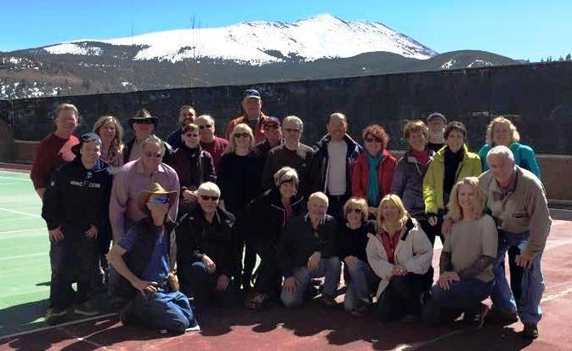Breckenridge 2015
By Mary Randzo
On Saturday, March 21, 2015, thirty South Jersey Ski Club members flew nonstop on Southwest Airlines from Philadelphia to Denver. We then boarded an Arrow bus to Breckenridge, Colorado. Approximately, one hour into the ride, we stopped at Applejacks to purchase wine, beer and other libations and at King Soopers for our food purchases.
We stayed at Beaver Run Resorts in Breckenridge with its’ ski in ski out capability located at Base 9. We were able to enjoy the hotel amenities which included hot tubs, swimming pools, restaurants and nightly entertainment or we could catch the Beaver Run Courtesy Shuttle into town. Breckenridge has the Free Ride bus system that allows you to travel anywhere in Breckenridge and Summit County.
We had a festive time on the bus getting to know each other as 15 of the 30 skiers were new ski club members who signed up just for the Breckenridge Trip. Our new skiers were Tom, Jonathan, Diane, Zachary, Cindy, Carol, Joanne, Cheryl, Joe H., Joe C., Dayna, Craig, Frank, George and Mike. And, I might add at the end of the trip all 15 new ski club members said they cannot wait until August 12 to sign up for another one of our trips.
Saturday night upon arrival and after checking into our hotel rooms and condos, we had a Hotel Welcome Reception in the Peak 14 Room, with wine, beer, soda, water, cheese, crackers and fruit. The hotel representatives discussed the many options Beaver Run had to offer as well as what the town had to offer in terms of fun – snowmobiling, dog sledding, cross country skiing, snow shoeing, etc. At the Welcome Reception, the skiers were able to get to know each other in a more relaxed atmosphere.
Sunday was the first day of skiing on Breckenridge, everyone went skiing and later met at the Base 9 Bar for Happy Hour. Good to excellent skiing conditions were reported.
Monday night after a day of skiing, we had a SJSC group party at Taddeo’s where we dined on appetizers of Calamari and an Antipasto salad, a wonderfully big Taddeo’s salad, and gourmet pizzas as well as alcoholic beverages. The group discussed their ski experiences of the day and were able to view pictures taken by each other. Everyone was excited to see it snowing! At dinner tonight, I learned that Jim O was a skilled skier that was willing to share his knowledge with us.
Another day of skiing on Breckenridge, the Après Ski Party on Tuesday, we met at MiCasa for 3 for $5 tacos and drink specials. Thank you for Joe K. and Eileen for picking up the first round of drinks!
We woke to snow on Wednesday, some skiers took the opportunity to ski the bowl; while others took the day off. Bob and Lorraine reported that they skied Breckenridge on this snowy day and it was the best conditions conducive to powder skiing. Dayna, Joe C., David and Mike went skiing at Arapahoe Basin. Terri, Cindy, Mary and Paul went to the Breckenridge Nordic Center for snow shoeing. Later the group met at the Breckenridge Brewery for Happy Hour. Joe H. and Cheryl went snowmobiling. When not skiing, Craig who shipped his bike to Breckenridge, was pedaling around getting to know the town much better.
Thursday, Geri, George, Dayna, Rich and Mike went to skiing at Vail. They reported good skiing conditions. Tom and Jonathan went to Keystone and also reported good conditions. Another group Happy Hour at Mother Loaded Tavern was scheduled. When not skiing, Bob B. was pursuing the perfect hamburger in Breckenridge, which he found at Ollie’s. Susan not only displayed that she was an avid skier by skiing everyday but also showed us that she was our skiing fashionista with a different, coordinated ski outfit each day. I would not have known this however one of our Facebook members pointed this out from Susan’s pictures.
Friday, people skied at Breckenridge, I even took ski lessons. Après Skiing, we met at the Base 9 Bar for Happy Hour. After Happy Hour and discussing skiing and ski conditions, Eileen, Joe K. Cindy, Tom, Harold went to Fatty’s for pizza.
Saturday, thirty happy skiers loaded the bus on the way back to the Denver Airport to catch out 5:30 p.m. Southwest flight back to Philadelphia, where we had mixed emotions. The weather and ski conditions, that many worried about ,turned out perfect for Spring Skiing in Colorado. After all, Breckenridge claims to receive the most snow in March!

