# **Annual Canoe and**



# **Kayak Outing**

# **Saturday June 20, 2015**

**Paddle the Great Egg Harbor River with the SJSC!**

**Pack your boat and meet us at the Palace Outfitters/Restaurant in Weymouth, NJ at 9:30 a.m. on Saturday morning June 20th. If you don’t have a boat – don’t worry…you can rent a canoe or kayak (make your reservation with SJSC, then pay in CASH when you get there - $32 for single kayak; $50 for canoe or double kayak); $7 for porting your own kayak/canoe. Bring your cooler, beverage, bug spray, camera, hat, etc… the Palace will be portaging us upstream to where we will put in…the trip downstream to the Palace will take about 4+ hours depending on water level and swim and break.**

**This year’s after-kayak party will be at the Morgan’s.**

**BBQ party details available on the SJSC Website and FaceBook pages…**

**We will limit the number of boaters to 30 to avoid too much congestion on the river. Also, there is a registration deadline of June 12th (or earlier if it fills up before then), whether or not you have your own boat!**

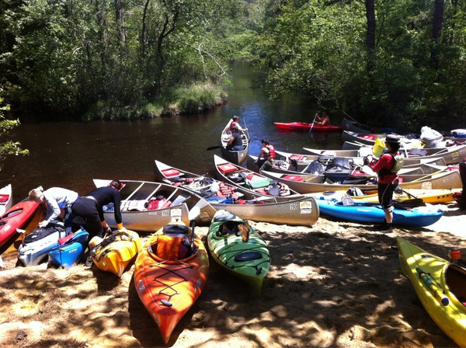

**Contact Paul Serdiuk pis9@yahoo.com or 609-462-3593 (evenings) if you plan to join us (including those using their own boats) and to make a rental reservation.**

[www.sjskiclub.com](http://www.sjskiclub.com)