Diana Krall and SJSC at the Mann Music Center
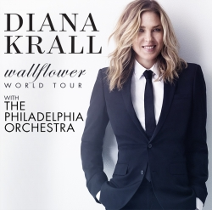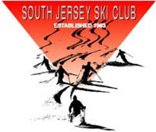
Diana Krall returns to the Mann with the incredible Philadelphia Orchestra. In addition to her lush orchestral standards, Ms. Krall will also perform hits including such pop classics as The Mamas and the Papas' "California Dreamin'," the Eagles' "Desperado," and Bob Dylan's "Wallflower," all from her new album Wallflower set to be released on Feb. 3rd. Don't miss this unforgettable evening only at the Mann. Tickets are on sale now via MannCenter.org, Ticketmaster.com, 800-745-3000, or the Mann's Box Office. Plan to join us on the lawn area with your picnic dinner and drink.
Date: Friday, July 24, 2015 8:00PM Links: http://www.dianakrall.com/
Tickets: $25 - $85
Details: Doors open: 6:00PM, Showtime: 8:00PM
Meet: On the grass area around 6:00pm. Bring blanket or low rise lawn chair, a picnic dinner, and wine or beer.
Contact: Paul Serdiuk pis9@yahoo.com for additional info

