From the [All Trips] listing, click [Register] for the trip you are leading;
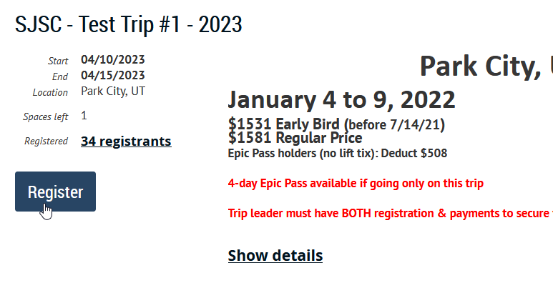

Once you click thru the email address entry, you’ll see:
Standard Package (Early Bird Price)
(this, instead of the alpha-listing of various price-points A thru Z)
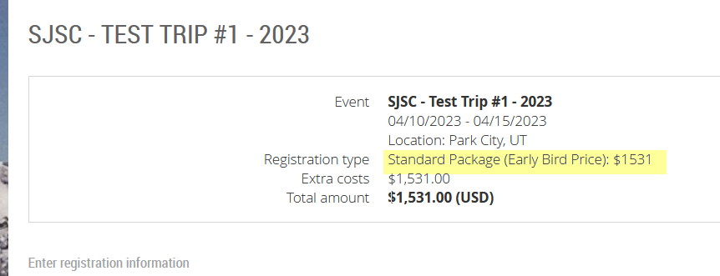
You are now IN the trip registration, scroll down to enter / confirm all personal information…
As you scroll down further, you get to [Trip Package Selection] – where you get to customize your trip:

This 1st choice to make… accept the default option w/ Air.. or choose Land Only
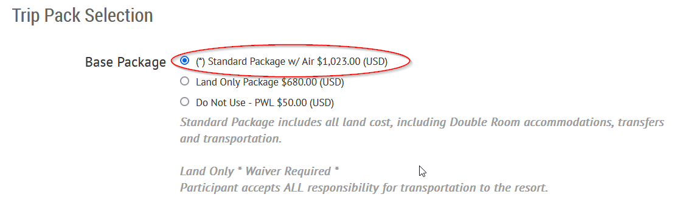

Then you have other choices to make on all other trips options (Double vs Single, w or w/o Lift, extra lift and/or other activities that may be included as options).
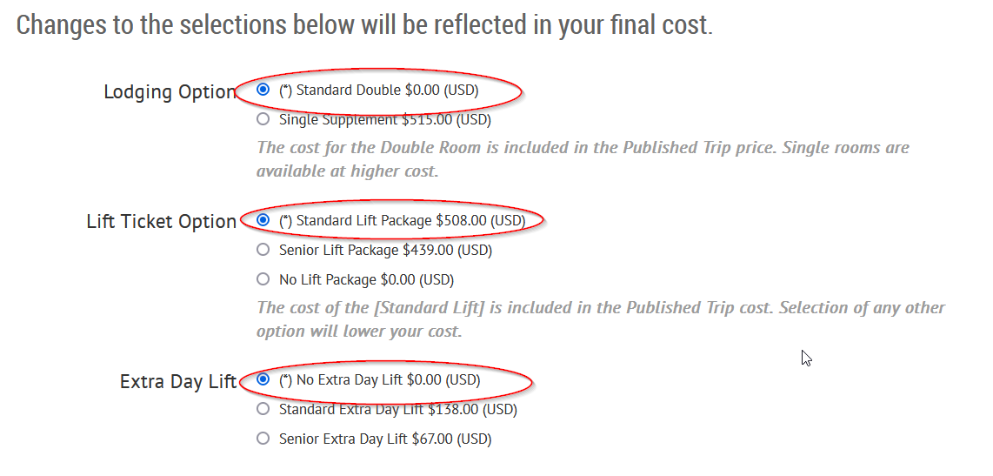
>> If a senior priced option were available for a trip, it would be listed here.

EARLY SIGN UP ONLY (including Trip Leader Registration)
When you get to [Roommate information] – aside from normal info (Name, Address, Cell #)… if want to register a non-ESU Eligible Member to be your roommate during the ESU Window – you must enter their correct email address in the field shown.
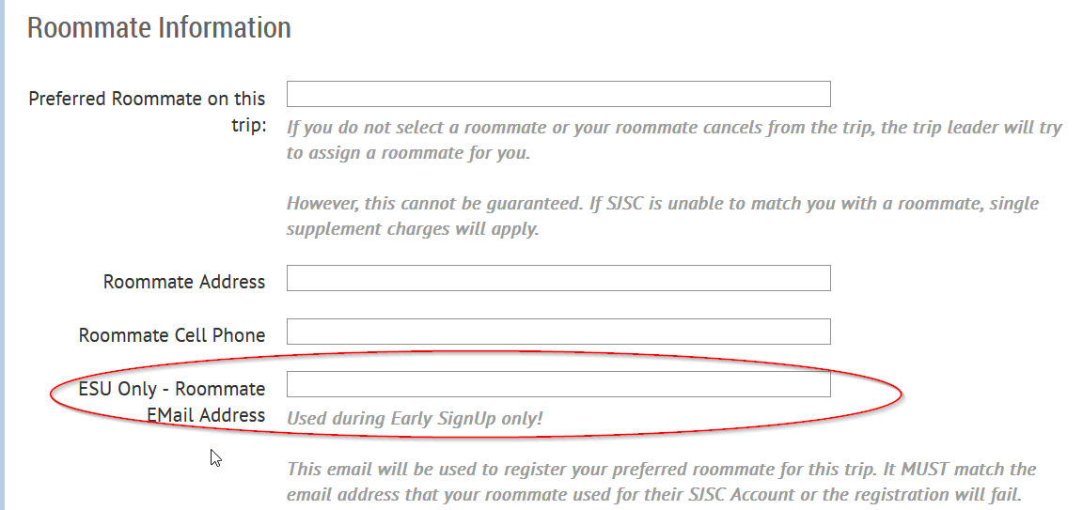

With that address, your roommate will be registered for the trip (Std Package) so long as their account is current. (If they are not current, w/ all requirements met, the registration will fail.)

NOTE: If your roommate is eligible for the ESU (or TLR), then do not put their email address in this ESU Only field! They should register for the trip themselves.

When you get to the end of the registration, you’ll get a summary that shows the final price. If you had left all options at their default assignment – you will have the Standard Package… at the correct price.
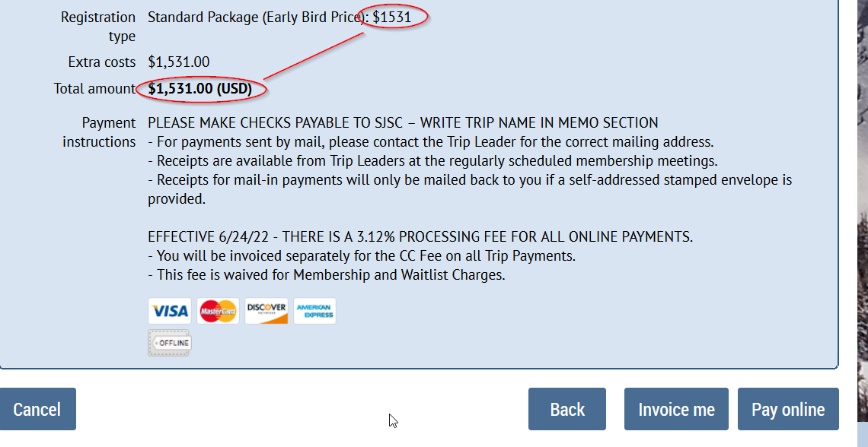

Any changes to the options selected will result in a different (but correct) price for THAT selected package.

If a roommate registration fails, you will get an email advising ‘why’ it failed (bad email address, dues not paid, HHA not on file, membership lapsed… whatever).
During the ESU/TLR Window… there is opportunity for the named roommate to FIX the problem… and then notify the Trip Leader to ‘re-process’ the registration.
For all cases (except bad email) – all that is needed is for you (Trip Leader) to edit the primary registration… and type ‘y’ in the field [ESU Reprocess] at the end of the registration form.

This registration will be re-processed (15 min cycle) and – if all aspects of the named roommate account are good, then the registration will be completed. If, however, there is still anything wrong w/ the account – it will fail again.
(Example – they pay their dues, but do not process the HHA that was sent upon payment.. the account still not fully active).
If the original problem was a bad email address, then you – as trip leader – will need to enter the corrected address in the ESU Field
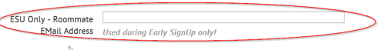
AND type ‘y’ in the [ESU Reprocess]

