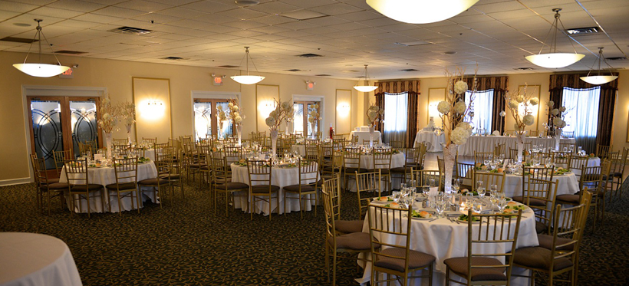

Friday, November 20th

The SJSC annual BASH will be held at the wonderful Tavistock Country Club. This is our fall extravaganza. Enjoy the Grand Buffet, dance to the DJ music of Donato Brothers; enjoy the cash bar, and a chance to win some fabulous prizes.
Tickets are available at the November general meeting or using Paypal on line at www.sjskiclub.com
Price is $40 per person…price goes to $45 on November 1st
Contact Paul Serdiuk for more info at pis9@yahoo.com

