NEW MEmBERS and regular Happy Hour at Miller’s Ale House

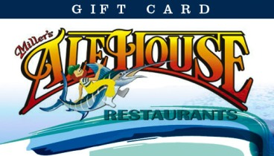

Join Mary Randzo and fellow SJSC members, new and regular, as we celebrate the Breckenridge trip reunion. Miller's Ale House restaurant provides top-quality food at a great value in a casual neighborhood tavern atmosphere. Choose between New York Strip, lobster, original pastas, fresh salads and favorites like Zingers® boneless wings and homemade desserts. Their full-service bar features more than 75 beers, plus wine and liquor. We'll meet at the bar to the right.

Where: Miller’s Ale House 554 Fellowship Rd. Mt Laurel, NJ 08054

When: Friday, April 10, 2015 5-7:00pm

Host: Mary Randzo 856-470-7368 mrandzo@yahoo.com

