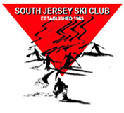

Happy Hour at Miller’s Ale House

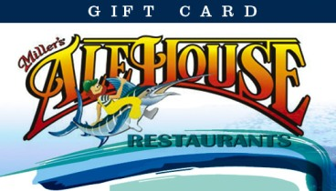

Join Mary Randzo and fellow SJSC members at the Miller's Ale House restaurant provides top-quality food at a great value in a casual neighborhood tavern atmosphere. Choose between New York Strip, lobster, original pastas, fresh salads and favorites like Zingers® boneless wings and homemade desserts. Their full-service bar features more than 75 beers, plus wine and liquor. We'll meet at the bar to the right.

Where: Miller’s Ale House 554 Fellowship Rd. Mt Laurel, NJ 08054

When: Friday, October 30, 2015 5-7:00pm

Host: Mary Randzo mrandzo@yahoo.com

