South Jersey Ski Club presents
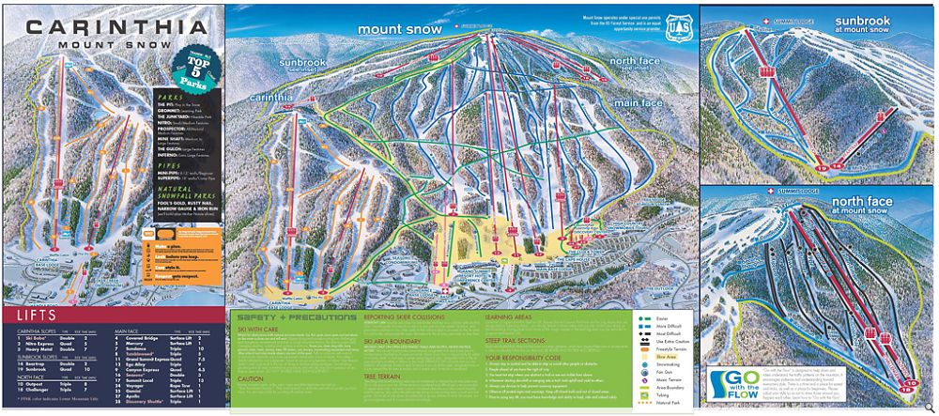

Mt Snow, VT
3-DAY SUPERBOWL
SKI SPECtACuLAR!

Jan 30- Feb 2, 2015

$595 Early Bird (deposit paid by 9.10.2014) $625 Regular (deposit paid after 9.10.2014)

Per Person based on double occupancy: If you do not select a roommate and we are unable to match you with one, Single Supplement Charges will apply
(note: Single Supplement availability may be limited.)

Includes: R/T bus transportation from Ramblewood Country Club (driver tips included)

200 Country Club Parkway, Mt Laurel, NJ 08054-2799 Bus leaves promptly at 5:00 pm Friday night.

Bring your own food and beverages for the ride; cups and ice (for beverages, not to fill coolers) are provided, we do not make a dinner stop. Box lunch provided for ride home

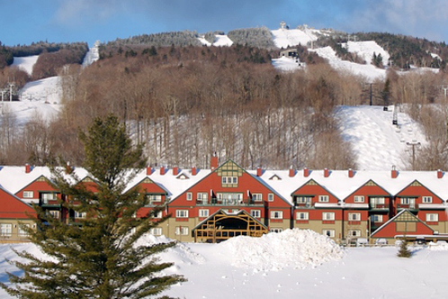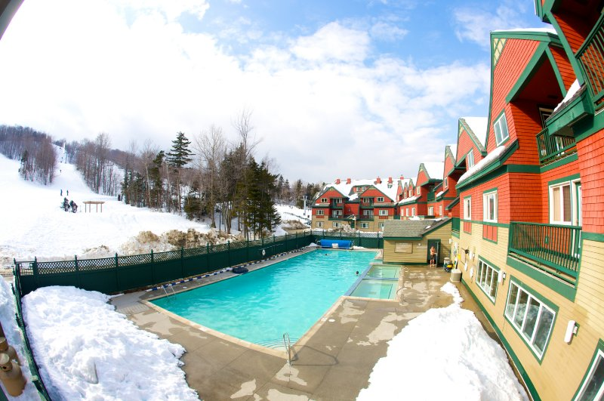
3 nights at The Grand Summit Resort
89 Grand Summit Way, West Dover, VT 05356
Phone (802) 464-4040
Three Breakfast vouchers
SUPERBOWL PARTY ON SUNDAY!

WiFi, Spa, Outdoor pool and hot tubs, restaurants, bar, Ski Shop, Room Service…Two consecutive day lift tickets, add third day for $40…Ski in/ski out, Walk to Snow Barn for entertainment, Outdoor ski valet, Snow tubing at Hotel

Your membership in SJSC must be current to participate
(EPSC members have reciprocity and may participate at the regular price; early bird pricing for SJSC members only)
Both pages of a trip registration form must be completed and signed to be added to the trip or wait list.
See www.sjskiclub.com
Trip Leaders
Jean and Jeff Hayfield 856.912.1682
jeff.hayfield@yahoo.com jean.hayfield@yahoo.com
2407 Locust Ridge Rd., Pocono Lake, PA 18347

for membership information

Please make all checks payable to “SJSC” – write trip name in memo section
There is a 2.75% cashier fee for using a Visa or MasterCard. Receipts returned for mail-in payments if a Self Addressed Stamped Envelope is provided, otherwise, receipts are available from the trip leader at regular membership meetings.

Payment Schedule Cancellation Schedule (Your Liability)*
Signup 8/13/14 $250 Prior to 9/10/14 $250
Due 9/10/14 $100 10/8/14 $350
Due 10/8/14 $100 11/12/14 $450
Due 11/12/14 $100 12/10/14 $550
Due 12/10/14 Balance $45($595/$625) After 12/10/14 Total amount of trip

*This is your maximum liability. Actual refund will be determined when the trip books close. A minimum cancellation fee of $50 is charged in all circumstances.

Due to the ever changing circumstances that exist in the travel industry - all prices are subject to change. Consider purchasing optional Trip Cancellation Insurance. If you need to process a claim, contact the trip leader, not the outside vendor, for documentation of costs. Trip participants are responsible for any fees that may be incurred outside the control of SJSC, including but not limited to: fuel surcharges, baggage fees imposed by an airline, costs incurred by weather related delays or cancellations, currency fluctuations on trips outside the U.S.

