FALL FOLIAGE HIKING & CAMPING WEEKEND -North South Lake
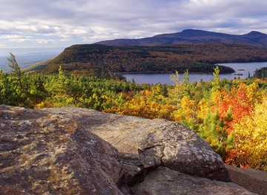
Hike and camp at North-South Lake State campground at Haines Falls, NY in the Catskill Mts. This is a great time to hike and see the spectacular fall foliage in the mountains. North-South Lake is the biggest and most popular state campground in the Catskill Forest Preserve, offering extraordinary scenic beauty. Several lakes are located within the campground. The surrounding mountains contain numerous hiking trails, which lead to spectacular overlooks, waterfalls, and historic sights, like Alligator Rock, Kaaterskill Falls, and the former site of the Catskill Mountain House. On a clear day, five states are visible from some overlooks. The campground is 2.5 hour drive from SJ. We are camping in Loop 6. If you cannot campout, join us for the hikes either day.
When: October 5-9, 2015
Contact: Paul Serdiuk pis9@yahoo.com or 609-462-3593
Directions: GPS Info. (Latitude, Longitude):42.1984, -74.04496 42°11'54"N, 74°2'42"W
From the South: Take the NYS Thruway (I-87) to Exit 20, at Saugerties. Follow Rte 32 north for approximately 6 miles to Rte 32A and Rte 23A West. Stay on Rte. 23A to the village of Haines Falls. Make the first right turn in Haines Falls, onto County Rte 18, and follow it to the campground entrance. Contact Information: NORTH-SOUTH Lake Campground P.O. Box 347, County Route 18 Haines Fall, NY 12436 Phone Number: Office: (518)589-5058

