SJSC Okemo 2017
Trip Recap
By Caroline Smart

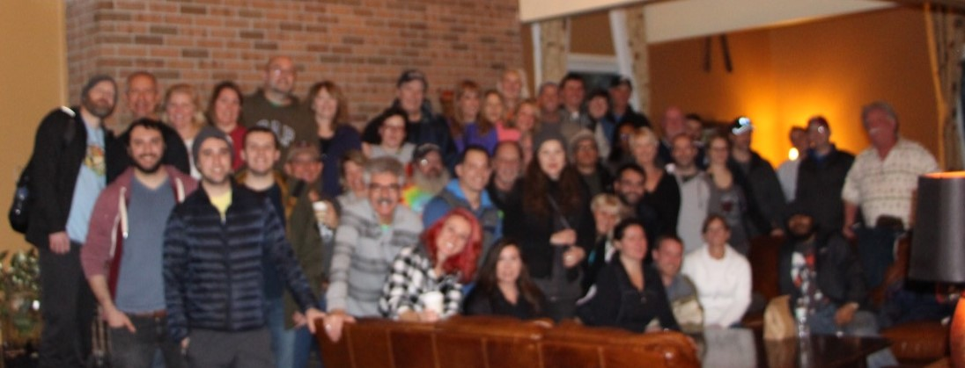

We arrived at Ramblewood CC on a rainy Friday afternoon to find that the bus would be 30 minutes late, and everyone rallied to load it up quickly and get on the road by 5:15. George B made it onto the bus despite a stomach bug earlier in the week, while wait-listers Alex D and Griffin D benefitted from a last-minute cancellation. Once on the bus, the ski club provided gift bags of snacks and water, Harry W. provided soft pretzels, and the trip leaders provided moonshine cherries to all who dared to partake. After a driver change and pick up at Exit 9, we were on our way. And before long, the sing-a-long at the back of the bus was in full swing.

Arriving in downtown Ludwig at 11:30 we noticed that the restaurants and bars were empty. They wouldn’t be empty Saturday night! The hotel welcomed us with comfortable rooms, even if the walls were a bit thin. Ralph P, Nancy P, Joanne H and Robert H were spotted enjoying and a nice hot breakfast Saturday morning. While many of us took our time getting out and about, the early risers took the 7:35am local shuttle to the mountain. A larger crew made it on the 8:35 local shuttle, and the remainder of the group waited for our bus at 9:30. Okemo here we come!

The mountain was friendly and gentle which helped with low visibility. Some members received a slope tour with the ambassadors and learned about the fire tower high above the cloud line.

Paul Z and Jessica Z enjoyed skiing down the mountain, coming out of the fog, and arriving at the Waffle Cabin to enjoy coffee and a waffle. Beth O, Ygor C, Ryan S, Steve L, and Derek T kicked off their day traversing the Mountain Road before heading out to the more difficult trails. Don M, Harry W, Irena F, Anthony F, Michelle D, and Kim S. were spotted skiing together. The outdoor fire-pit attracted many members including TJ M and Pat M warming up between runs. Recovering from a knee injury, Rob U. welcomed skiers at the Sitting Bull Restaurant throughout the day. Many members were spotted there enjoying drinks and listening to the Beatles tribute band while waiting for the bus. Several other members were spotted at the Loft, which was conveniently located next to our bus pick up location. Meanwhile, Ania M. enjoyed a lovely day of cross-country skiing with a local friend.

The hot tub at the Pointe Hotel was overflowing after a long day on the slopes. Some even ventured up the hill to the Castle Inn’s outdoor spa hot tub. At 7:00 Gregory transported a bus load of members into Ludlow for dinner and drinks. Sandy T, John T, Joe T and Lauren T, and Sharon B departed at the first stop for their Mexican dinner. Harry W, Bob F, Barbara P, Pat B, and Gwen D departed at DJs. At the final stop, some enjoyed a delicious meal at the Chop House that was well worth the wait, while the rest of the group filtered into Killarney’s. Live music entertained us while we waited for several tables. We ravenously enjoyed our meals and headed back to the hotel to rest up for Sunday. Mike R, Carolyn S, Denise R and John R eased their sore muscles in the hotel hot tub before bed, while Rishi G, Chip S, and a few others continued the party at the hotel.

Sunday morning started out great, though a bit foggier than Saturday. Mark M was spotted dancing to the tunes on the deck at the Sugar House lodge with Nina H Sunday morning before they headed up to the Glades Peak Quad. Meanwhile, George S. earned bronze on the NASTAR course.

The rain drops that started falling around 1:00 put a damper on the afternoon, but by then we were ready to clean up and watch some football. Unfortunately, Lisa J’s 1:30 ski lesson continued in the rain.

Back at the hotel, Bill C and Laura C kept warm by the lobby fireplace. Pam T and Patty J helped unload and organize our dinners while we watched the Falcons knock out Green Bay. Tim O managed the bus-loading operation to ensure our luggage and gear fit better than the way up. After the group photo in the lobby we were on our way home!

Once on the bus, many watched the Patriots edge out the Steelers on our phones, while others watched Lane Meyers ski the K12 in Better Off Dead or took a well-deserved nap. Despite Laura K’s knee injury, she and Bob A seemed to be in good spirits. We hope you’re feeling better, Laura!!!

Back at Ramblewood CC a team effort ensured we quickly unloaded the bus to be on our way. Thanks to everyone for making this another memorable SJSC experience!!!

