Oldest Restaurant in New Jersey
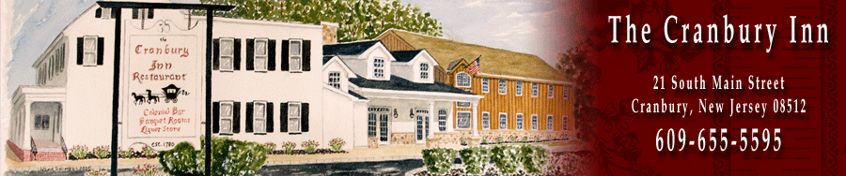

Cranbury, NJ (Est. 1750)
In the mid 1600's in the center of the colony of New Jersey by Cranberry Creek, a mill town began to develop along an old Indian trail that had widened into a road. This road connected the colonies and was becoming a main thoroughfare for colonial travelers. In 1697 Cranberry Towne received its charter from England. With increasing development, a need arose in central New Jersey for a place to eat and drink, get fresh horses, and spend the night; thus in the mid 1700's our taverns were built to meet these needs of the travelers passing through this area. After the colonies declared their independence from the motherland this business officially established itself in 1780. What is now The Cranbury Inn has been functioning as a place to eat and drink since the mid 1700's.

Date: Sunday, October 18
Meet: 9:30 a.m. –for a leisurely Historic Walking Tour of Cranberry
11:30 – Option to have Brunch at the Cranberry Inn or lunch in the lounge, which is located in the oldest original colonial tavern here at The Cranbury Inn.
If you are having Brunch it is $25 plus tax and tip and need to register with host.

Host: Mary Randzo mrandzo@yahoo.com

