riverwinds free outdoor concert
with Julianno Brothers

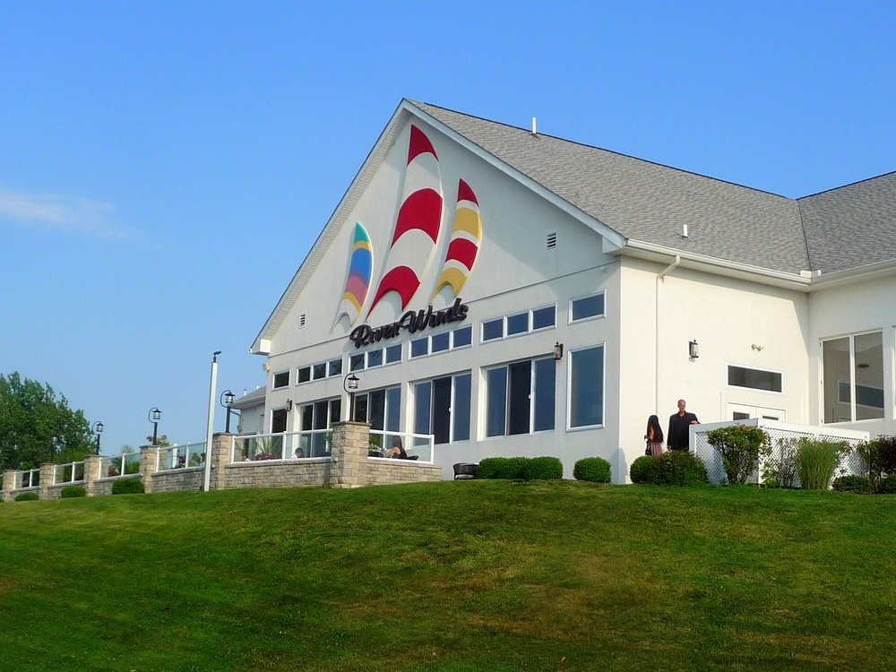

Riverwinds Community Center
1000 Riverwinds Drive, West Deptford , NJ
Friday, June 5, 2015 8:00 PM
Bring a lawn chair or blanket with you

The Juliano Brothers are playing outdoors
There will be food and drinks available for purchase
NO BYOBs or coolers allowed.

Meet near the amphitheater

Host: Paul Serdiuk pis9@yahoo.com

