SJSC STEAMBOAT TRIP 2015
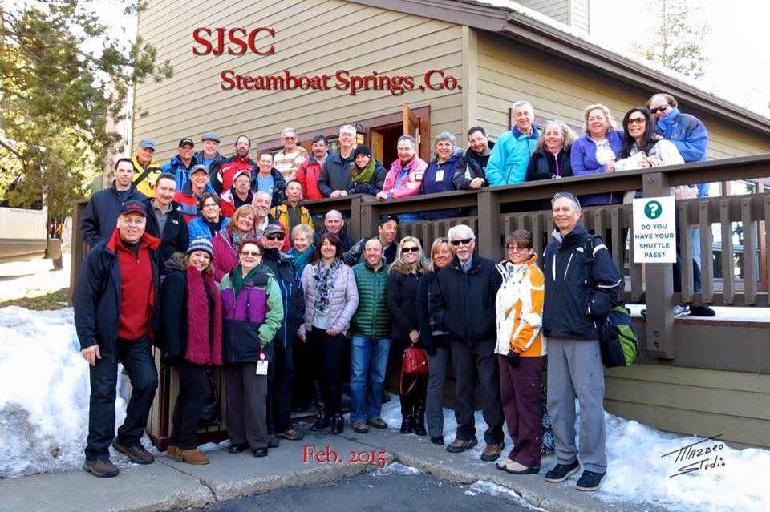
By Michelle Tieniber
Feb 7th- Feb 14th, 2015
An excited group met at the Newark International Airport early on Feb 7th for our direct flight to Hayden Airport. Forty members of SJSC arrived early in a 4 hour dash, greeted at the tiny airport as if we were family coming home, then on our way to the Lodge at Steamboat via the friendly crew at Storm Mountain Express, where two others Carol & David met up with us from Atlanta.
We were met with smiles and an awesome welcome reception by Carter of Wyndham Properties and our Steamboat representative Angie. As we shared appetizers and a glass of wine or beer we listened to all the exciting events and all that Steamboat has to offer. Carter shared information about the Lodge amenities and the Fireworks celebration to come that night. Angie spoke of the Mountain tours, the BBQ dinner we were about to have on Sunday night, and the other Masters tour, Snowshoe tour and Happy Hours in our future. We checked in to find our luggage already there, and settled in but not for long- most headed downtown via our friendly shuttle drivers, to see the Fireworks, lighted man, torch parade and Yes more fireworks! It was the 100th Winter Carnival finale at Steamboat and they did it right.
Early Sunday morning the sun was shining and 30 of us gathered at the top of the Gondola to meet our Mountain Ambassadors. We split up into small groups advanced & intermediate and headed out on the slopes. Many of us skiing for the first time in Steamboat appreciated the guide and asked all kinds of questions along the way. Our guide Don, even stayed and had lunch with Terri, Tom, Michelle, Mary & Eric. We realized we had been skiing with an Olympian!- our very own Tom N, was in the 1968 Olympics and told us stories of his time in Grenoble.
Sunday night we all gathered in the clubhouse ready for our Western BBQ dinner at Thunderhead Red. We rode the Gondola up to a feast of Carved Prime rib, BBQ ribs, and all the delicious sides. Stephanie, Debbie, Carol & Michelle were among the first to join a western line dance, followed by Laura & John doing the Cotton Eye Joe. The music continued and the drinks flowed as we had delicious desserts of cheesecake and brownie sundaes. As the night went on the music got funky and some classic rock tunes encouraged Jack, Janet, Michelle, Debbie, Mary, and Steve to get out on the dance floor. It was a terrific event that ended with a beautiful ride down the Gondola to see the lights of the downtown.
Monday was another Blue Bird day, with lots of great skiing. Groups headed over to Mountainside through the Glades- Bill had his Go Pro filming the fun along the way while we skied and boarded through the trees and into the sun. Earl & Donna and others did the Masters all day tour with guide and said it was an awesome experience, tracking their day on a ski app. There was talk of snow that night as a bunch of us met up on Bear River deck aka “Steamboat Beach” for a cold beer and sharing our day. That night a group of us headed over to La Montana for a gourmet Mexican treat. The restaurant and bar were so close to our condos it became a favorite of many for the week to come.
Tuesday brought 4” of new powder and many headed out early to get fresh tracks. Many also decided it was a day to take in the downtown and the many shops /restaurants offered there. Michelle & Linda shopped and had lunch, and Sue & Don were out on the town also along with others. Tuesday was our planned trip to the Strawberry Parks Hot Springs and we again met in the Clubhouse at 4:15 with our bathing suits, robes, towels, and drinks ready to go. The number of participants kept growing as the excitement over the Hot Springs spread throughout the group. Geoff & Kathy who came up from Vail joined us as well as Jessica from Denver. In all we had almost 40 people, in 3 shuttles heading into the wilderness of Strawberry Park. It was a relaxing and fun night as the sun set around us and we lost the daylight. Reluctant to leave we made our way in the dark with flash lights back to our shuttles for the ride at 730 pm.
Wednesday was another Blue Bird day that lead a hungry group to the new Four Points lodge for lunch. We sat outside in the sun and ate Bison Chili , salads and burgers eager to then get back on the slopes. Terri was busy setting up our Nastar racing for Friday and we recruited 24 group members to sign up and fill out forms needed to get set to race. A busy day was followed by a busy night downtown for many and groups went to Mahogany Grill, E3 and 8th Street Steak House for some delicious Bison & Elk Steak dinners and craft beers.
A partly cloudy Thursday turned into another sunny day where most skied all day, while a few- Terri, Geri, Rich and Laura headed out with the Snowshoe guide at 1pm for an adventure on the mountain. The first of some Mardi Gras events was Thursday night and 20 of us headed again up the Gondola for the famous Sunset Happy Hour. TJ, Chip, Rich and Ed enjoyed the outdoor deck with many others. The sunset was incredible display that lit the sky like a fireball and lasted for at least an hour. We had some wings and appetizers with drinks and danced to a great band from 5-8 pm.
Friday was race day!! Nastar in Steamboat was such a blast, many racing for the first time including Michelle, Debbie, Geri, David H, Stewart, Steve and many others. We met up at 915am eager to try a test run before the official start of 930am. The races continued for a full hour as John & Rich K took Gold! Michelle, Debbie, Terri, Eric, Pam, Ed, David P & Chip took Silver, and Mary, Donna, Earl, Sue, Rich K, Janet, Jack, Fred & Jeff took the Bronze. Many raced and just missed a medal but all had a great time, racing against friends and just to get a better time. Our club standing is now 101 out of 1394 teams in the Nation!! Thanks to everyone who participated that day and to Terri who set it all up for us!
At 3pm it was ‘Steamboat Beach” our final Happy Hour as we gathered to dance and sing along with the band. Terri gave out our Nastar Medals on the deck that afternoon, and the group enjoyed the sun and some Apres ski fun.
Our departure day was another sunny one, as we arrived back in Hayden for our direct flight home. Little did we know that our plane that landed for our return, had a maintenance issue aka toilets broken, that caused a huge delay from our original 12noon flight til almost 530pm. We were given updates about a new plane and some food vouchers and finally got on our United flight to Newark despite the warning of high winds and snow in New York. It was a smooth flight with many apologies from United, some free drinks and a $50 voucher for a future flight. The delay caused our group to have to bear the snow and winds late at night to get home. Hopefully everyone got to sleep in on Sunday with great memories of the Colorado sun that kissed our cheeks all week and great skiing & boarding in Steamboat. I certainly hope to see you on a Western trip in the future! Happy Trails everyone!!

