SOUTH JERSEY SKI CLUB IN SNOWMASS-ASPEN
FEBRUARY 11-18, 2017
By Geri Benedetto
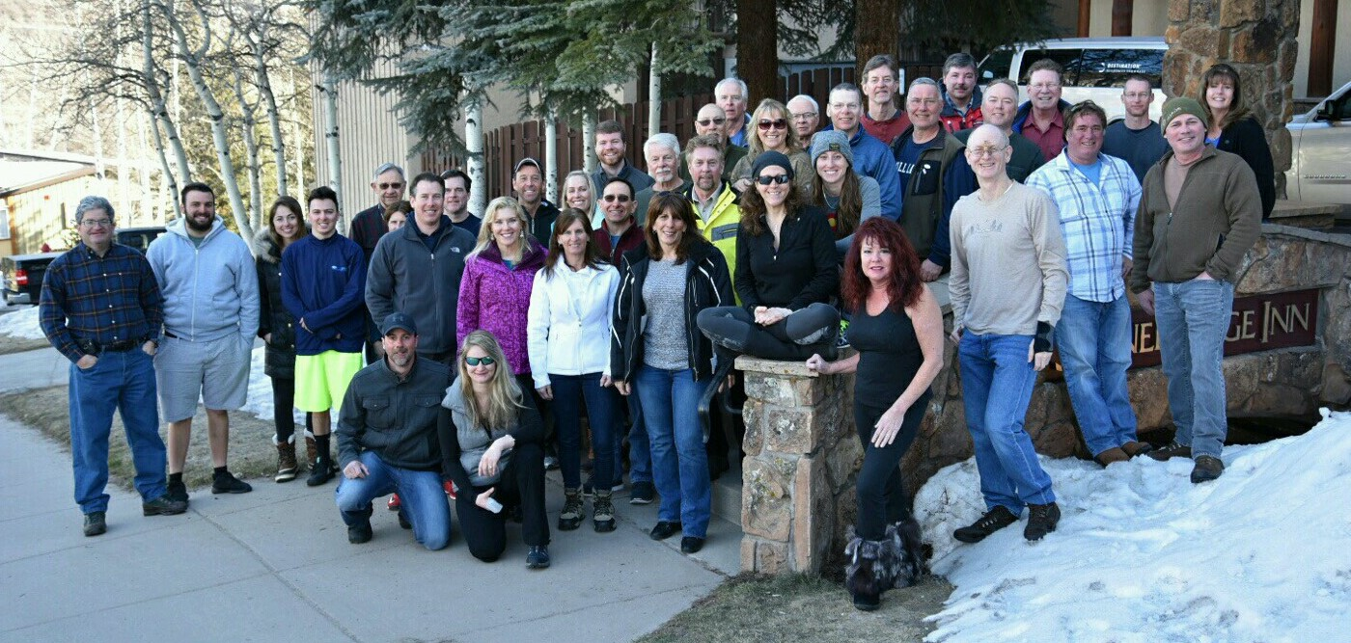
South Jersey Ski Club had a smooth departure from Philadelphia and were on our way to Snowmass when two trucks were blown off I-70 by high winds and shut the highway down for a couple of hours. Nevertheless, there was dancing in the aisles and the seats and our resilient group made the best of the situation. We arrived at the Stonebridge Inn in Snowmass after a couple of important stops with a minimum of the usual chaos and began our ski week.
We welcomed new friends Sean K., Alexa M., Dennis P., Sabine C., Rachel L., Joe M., Phil B., Roger K., Lew M., Dean A., Debbie and Jeff S., John R., Tom A., Jr., Melissa S., and Patty J. Our first day of skiing on Sunday was a glorious adventure at Snowmass with plenty of remaining powder. Sunday evening at our Welcome Reception we had a Build-Your-Own Baked Potato Bar and other carbohydrate goodies and became acquainted and reacquainted with each other through a bonding exercise in which skiers self-identified their ski abilities with stickers. Awesome skier Chip S. wore double greens!
On Monday, Mary D. and Rachel L. demoed powder skis but the powder had vanished overnight (other than in the highest areas and some glades) into hard pack and Cap’n Crunch for the rest of our week. Many of our elite team (Chip S., Pat D., George S., George B., Steve R., John S., Bobby A., Pam T., T.J. McS.) hopped on the bus to ski Aspen Highlands. One day, Pat D. and Pam T. hiked the Aspen Highlands Bowl. There were other hikes: John S. and Bobby A. hiked Burnt Mountain Glade. Tom A., Sr. and John R. hiked to the Snowmass Village for stew. Pam T. demonstrated real skill by performing handstand at the Cirque Headwall. Joe M. and Phil B. loved 12,000 feet and 3-knot winds for an entire week. Rich K. loved the terrain at Cirque Headwall with Sabine C. and Roger K.
Maryann T. rocked the bumps with Ralph and Nancy P. T.J. McS. and Pam T. rocked the glades and gulches between Big Burn and Sheer Bliss ski areas. Patty J. and Laura K. bonded on the slopes and enjoyed skiing together. Cousins George B., Michael T., and Rachel L. had an awesome time skiing and hanging out together in the West. Dave H. had a great lesson that was a real game changer for his ski week. Rich K., Chip S., George S., and John S. took bronze medals at NASTAR and Rich R. and Dean A. got silver. Great job, everyone who skied for SJSC’s NASTAR!
We had our share of the walking wounded: Pat D. “rocked” the Cirque Headwall when he bravely survived some snow-covered rocks and hung in for the rest of the week’s partying. Sabine C. skied steeps and glades with Rich K. and Roger C. only to sustain a freak injury on a blue flat traverse in the final moments of the week. Roger K. came out of a flu bed to warm up on the double black diamond trail, Grinder! Rich R. knocked his hand but kept on skiing and practicing tai chi at night. Fran C. skied challenging terrain all week only to take a spill on the dance floor after some excellent dancing.
Our group had great experiences off the slopes as well. Jodi S. went to Krabloonik, a ranch of 218 Huskies that was also a gourmet restaurant. Alexa M. and Sean K. had a romantic Valentine’s Dinner at Jimmy’s Bodega in Aspen. Tom A., Sr., Tom A., Jr., and Melissa S. enjoyed live music at Limelight and spotted Adam Sandler at Hops. Laura K. and Bobby A. kept the great tunes flowing on and off the slopes. Geri B., Ed K., George B., Mary D., Michael T, and Rachel L had a memorable champagne lunch at Ajax Tavern, at the foot of the Silver Queen Gondola, on a day off hanging out in Aspen. We also had a “beautiful people” happy hour at Ajax Tavern with those insanely delicious truffle fries thanks to our excellent advance team of Thomas A., Matt D., and Fran C. Later on in Aspen some visited Sky Bar and the Red Onion for the penultimate night party. We had three memorable happy hours at slopeside Mexican restaurant Venga Venga, and the last night we had an amazing dance party for hours. It was the perfect ending to a fun-filled trip to Aspen-Snowmass.

