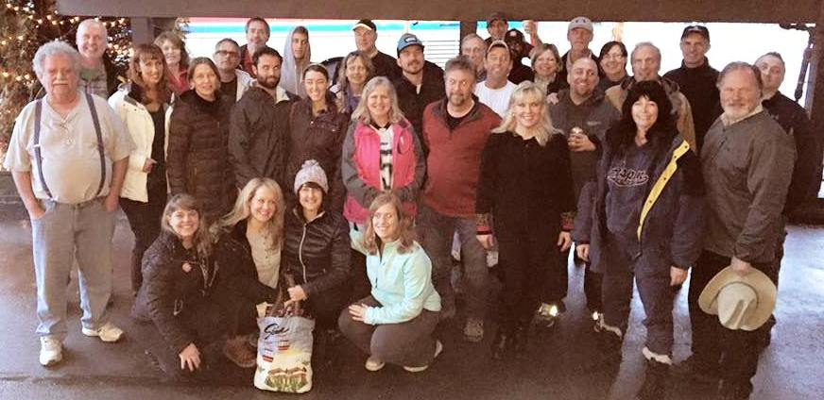
Stowe, VT Trip Recap - January 8-10, 2016
By Michelle Johnson

It is 5 pm and we are ready to pull out of the Ramblewood after roll call, but wait another car is pulling up. I take a poll and ask the group, “Should we sing the late song?” Only 4 raised hands, therefore we did not serenade them as they boarded the coach!! “STOWE HERE WE GO!” Harry spoiled us with soft pretzels and mustard. On to the exit 9 pick up. All aboard!!!! Spirits are high as there was dancing towards the rear of the bus, singing, music and laughter. Bob F had an unexpected ginger ale bath as a can of soda slid off the tray into his lap. Brian S took advantage of a nice nap on the bus. We had a quick rest stop near Albany and our group is on the road again. A few of us were watching the weather closely and hopeful for a perfect ski weekend in Vermont.
We arrive at the Commodores Inn and we are greeted by Tom P our Banchi Outdoor adventure rep Check in went smoothly and Tom met everyone in the lobby to hand out- lift tickets, rental and lesson vouchers. Most headed to their rooms to rest up and get their ski legs ready for the 2016 ski season. The rest of us headed to the hotel bar which was open for our arrival at 1:15 am. Harry, Rishi, Liam, Gary, Karen, Michelle J, Patrick M , Sandy and Bob F, enjoyed a night-cap and went to sleep around 2:30 am. Buffet breakfast was ready at 6:30 am and the dining room was decorated beautifully for the holidays. The Snow covered lake right outside the dining room put us all in the Skiing/boarding frame of mind. Irena, Don, Michelle D, Michelle T and Kimberly enjoyed breakfast before heading out Saturday by 9 am.
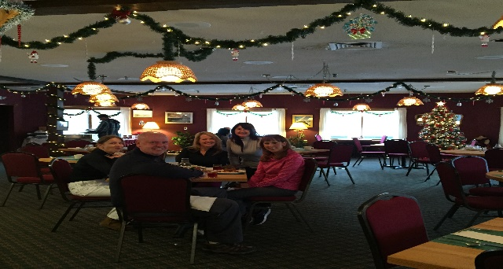Geri and Gwen, John and Sandy hit the slopes early on Saturday. Three of the four Michelle’s - Michelle D, Michelle J and Michelle T were greeted by two Stowe hosts , Calvin and Bob. They gave us a wonderful tour of the mountain and the Chapel on Toll road on Saturday Morning. Lauren and Mike met us for Lunch at Spruce Peak base. The flurries started on and off and it proved to be an awesome day. Conditions were excellent aside from some fog at the top.
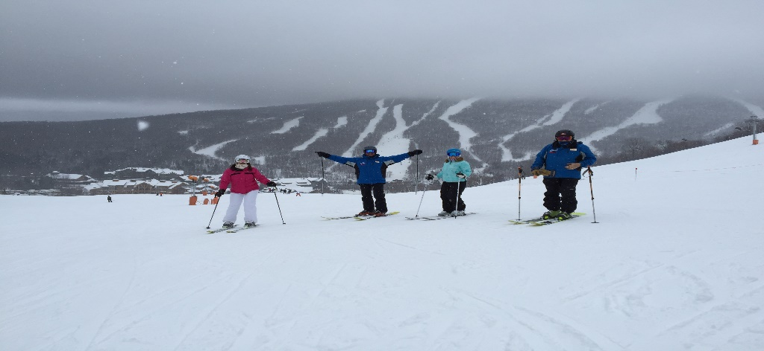
Stowe received up to 17 inches of snow over the week prior to our arrival. Jeffrey and Jules enjoyed Saturday skiing, Jules did a K2 ski demo. Kudos to Monty for joining the group, all the way from South Carolina. James D drove from NY on Friday Evening to meet Ed K. A couple of folks were under the weather but made the best of the weekend.
Karen K and Brian S and Barbara P took advantage of a 2.5 hour lesson and enjoyed Saturday Skiing. Patrick B and son, Austin B enjoyed time together at Stowe. The 20% savings coupon came in handy for some purchases at either base.
TJ and Patrick M. enjoyed the pool and hot tub/sauna. We all enjoyed a nice buffet dinner at 7 pm at the hotel and shared our stories of the day!! We enjoyed the lobby fireplace with so many comfy sofas. Most of us headed to our rooms and a few headed to the bar to continue the stories of the day.
Sunday - Many caught the 7 am mountain shuttle to hit the slopes before the rains came. Bill, Beth, Jules and Michelle J went to the book store and various shops in the center of town. The Rain started - pretty heavy and luckily we had two umbrellas - we still got pretty soaked but enjoyed our lunch at the Harvest Market - we warmed up and caught the shuttle back to the hotel.
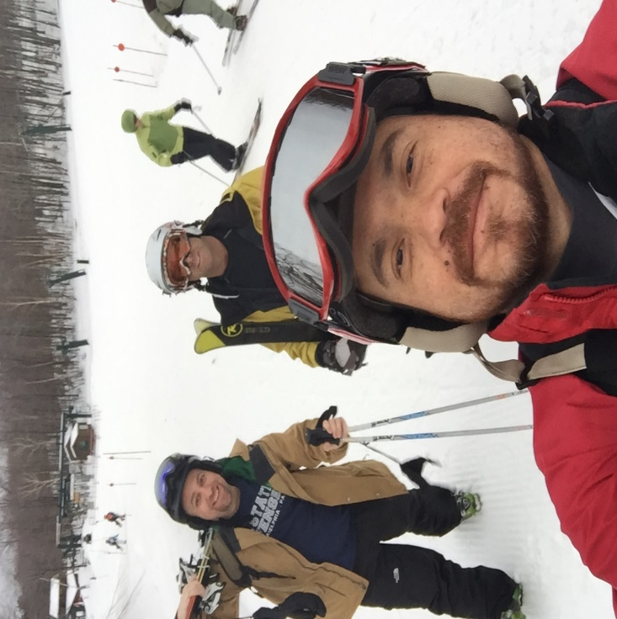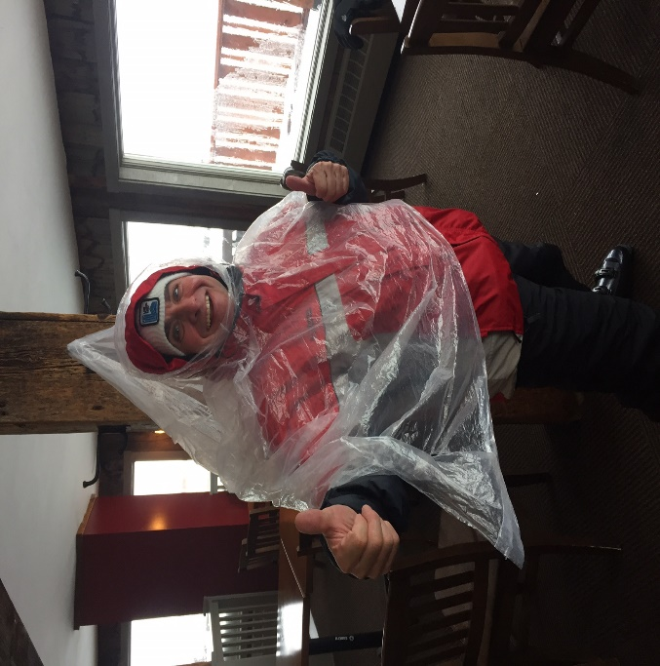
Liam, Chip, Jason and George hung out and had fun on Sunday. Around 3 pm on Sunday, we are all ready to go - we picked up our Boxed lunches, loaded and boarded the coach for the 4 pm journey home. We had a hilarious - gifty grab bag game on the coach to help pass the time. We watched 3 movies - 2 of which we could not see the ending- yikes!!!! The DVD player was not cooperating. We arrived at the Ramblewood by midnight – One lone boot bag was left in the lot and the rightful owner was reunited with it in a few days. Also two people grabbed the wrong board bag, but by the 13th of January at our meeting at PJ Whelihans - everyone had their equipment! I must say, This group was the best I have ever travelled with! Thank you !!!
Michelle Johnson - Trip Leader

