STOWE, VT
(2/20/15 – 2/22/15)
By Jen Dodd
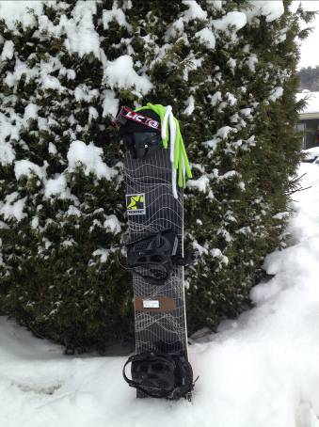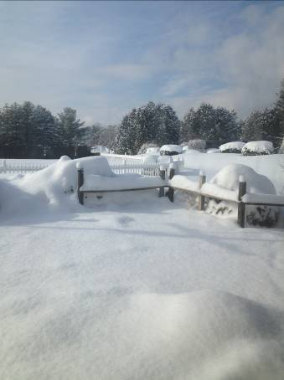

SJSC members, 52 in all, loaded the bus on a very cold afternoon and away we went to the Exit 9 pick up, where we picked up 5 of our SJSC members and continued our road trip to Stowe. Crazy hats were worn by many...

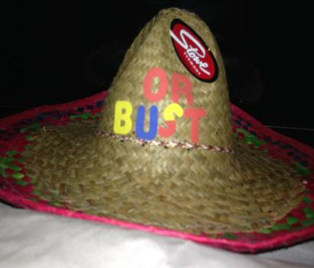Garry Dodd started the trip off with raffling off the case beer, which was won by one of our new SJSC members, Sharon M. With much excitement, she claimed her prize and continued to win items in the Bear Den (lodge bar) over the weekend. It was Sharon M.’s lucky weekend!

The hats didn’t stay on long before the libations were starting on what one would describe as the “ultimate party bus!” Thanks to Joanne H. for starting the party off right w/ the first round of Jell-O shots, followed by more Jell-O shots by Jen D. Between Joanne and Jen’s Jell-O making efforts we counted over 200 in all…YIKES!!!

We arrived safely at The Commodores Inn around 12:45am thanks to our awesome driver, Andre. Upon arrival, Garry D. handed out room keys and lift tickets. Many members went to bed so they could get on the mountain early; however, there were a few who headed to the hotel bar where our bartender Jay was very accommodating and the laughs continued.

SATURDAY
After a great breakfast buffet at the Commodores Inn (which was included in our trip), many were on the bus to Stowe at 8am. Karen K. posted the temps at -15 degrees. Can you say COLD!!!! By 11am, the temps made it to 12 degrees, which is a little more bearable. We saw many of our fellow members upon arrival at the Gondola: Chip, TJ, Pat M., Pam, Jason, Geri, Gail B., etc…And then we saw many more members (Michelle D., Kim S., Shaun P, and Ruvim Y., Deb G.) having lunch at The Cliff House restaurant, while Kim M., Garry D. and Jen D. enjoyed a Bloody Mary at The Cliff House. Many SJSC members braved the cold early. It was cloudy with snow expected to come in by the afternoon. The conditions were a little icy. It became a little tricky once it started to snow because beneath the thin layer of loose powder there was a layer of ice on many runs. Everyone was so happy to see the snow hoping for better conditions on Sunday morning. Pat B. who arrived on the trip sporting a cast managed to ski on Saturday despite a broken wrist/hand from an accident prior to leaving for Stowe. Impressive Pat B.!

While many of us were skiing, a few members Kate L., Jacqueline B., Julie F., and Sharon M. enjoyed other activities such as shopping, relaxing, and/or sight seeing. Jill D. had an awesome scenic “adventure” snowmobiling while we were on the slopes .

Of course, many members wrapped up their day at the Bear Den in the Mansfield Lodge, listening to some music and having a beer or two prior to heading back to the Commodores Inn. While Andre was stuck in traffic, I’d like to thank Garry D., Jason T., and Tony M. for the comedic entertainment on the bus as they told a few jokes to make the bus ride less painful in traffic.

Once back at the Commodores Inn, many members went to one of the 3 indoor hot tubs and saunas. The Commodores Inn provided SJSC members with a buffet dinner (also included in our stay) that included salad bar, steak, and Sheppard’s pie, chicken Alfredo, shrimp scampi, etc…Many members could not believe that the buffet was included. There was really no reason to leave the Commodores Inn other than to ski or shop! Many members enjoyed using their complimentary drink ticket (which was a nice added bonus) with their dinner or afterward in the hotel bar. Thank you Terri C. for arranging the complimentary drink tickets!

Once again, many members headed to the hotel bar after a very filling dinner to enjoy some bar tricks involving change, “The Garry”(which is a move Garry D. claims to have invented when falling from the snowboard and was hoping to patent, license and copyright “The Garry” by 1am), and Pat M. making plans to take back “our mountain” from the X-country skiers who were claiming some of it for their race on Sunday. (Pat M. and Garry D. should have followed through with plans to come out of the trees dodging the X-country skiers, because some members were upset that some of the trails were closed off due to the X-country skiers racing. LOL)

While the festivities were taking place in the hotel bar & the rest of the members were all nestled sound asleep in their beds, the snow gods provided us with much needed powder for a beautiful Sunday morning of skiing.
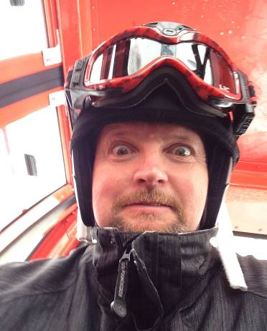
SUNDAY

On Sunday morning after our plentiful breakfast buffet, members loaded the bus heading to the mountain. Members were pleased to see the temps get up to 28 degrees by noon and about 8” of fresh overnight powder. Conditions were much nicer on Sunday. I think many of us were hoping we would get snowed in like those on the Mt. Snow trip a couple of weeks prior to enjoy one more day of skiing and boarding. Bill M. and Garry D. went Alpine, while I skied with Kim K., Julie F., Kristi M. and Drew M. While in the lodge, Barbara P. gave us the inside scoop to head over to TYRO – great conditions. Thank you Barbara P. for steering us in the right direction. I also enjoyed seeing Gwen D. and Geri B. Thank you Gwen D. for tips on how to avoid a boot bump and a bruise on my shin in the future. Of course, I saw Ed G., Tony M, and Bob I. briefly. It was a beautiful wonderful day at Stowe.

The bus picked us all up from the Mansfield Lodge at 3pm. We headed back to the Commodore’s Inn to change, grab our boxed lunches, and load up the bus. Andre had us on the road by 4:30pm and we all pulled in to Ramblewood CC to a parking lot full of black ice. Glad to report that everyone made it home safely. We are also happy to report that there were no injuries on the Stowe trip.

The Commodores Inn owner and group coordinator emailed the following to me:

Hi Jennifer,

Thank you so much to you and the South Jersey Ski Club for choosing the Commodores Inn for your ski vacation in Stowe. I am so sorry that I never had a chance to meet you. Hopefully you all enjoyed your weekend overall. I was in and out a lot as I had a huge race yesterday which took most of the day. What a treat to have all of that fresh snow yesterday morning and the temperatures were comfortable.

We do hope to see you all back again someday soon. Enjoy the rest of your winter.

Warm regards,

Carrie Nourjian
Commodores Inn

I responded of course thanking the Commodores Inn as well. We had a great stay. The staff was accommodating, friendly, and organized, which made my job and Garry’s job as leaders much easier. The hotel was rather clean, nice hot tubs, nice saunas, nice bar and bartender, and nice buffets. They also had a secure storage area for our skis and boards.

I asked for some feedback from our Stowe goers and here is what they had to say:

“Thanks for leading the trip to Stowe. Had a great time and the details were well organized. Thanks, Cindy M.”

“We had a great time on the trip this weekend and I just wanted to thank you guys for hosting the trip and being such great trip leaders! Joe and Maria A.”

“Great time for us Jen and Garry. Highlights great reliable transportation, great crowd of people, beautiful ski mountain from Bill, lodge was clean, comfortable with Jacuzzi great, good was surprised excellent for a hotel buffet was great, bar tender great costumer service. I don't even ski would come again prices were fair. Xoxox Sharon and Bill”

“Thanks again to you guys for a great trip. Gregg O.”

“-Great work, great communication, and great vibe.
-Best part = 9" of POW on Sunday, going extreme on Goat with Bill, George, Chip, and Ed. Pure magic, love it.
-Thanks for a great trip. Jason T.”

“One of the things I enjoyed so much was the diversity of Stowe. First there was a bomb-down-the-mountain day with Chip, Jim R., George S., Jason T. and others who came in and out of the group on Saturday. Then on Sunday, it was a leisurely green trail day on the Toll Road and the western part of the mountain with Gwen D. Sunday was a moving meditation on winter's beauty. It was also great to see so many new people having a blast with SJSC! Lastly, everyone was so great about the Route 9 pickup and that can open our club up to a wider population both north and south. Great trip!” Geri B.

“Thanks For a great trip, I had a lot of fun.” Bob I.
The price of the single supplement at this place was a steal (I thought)-I was pleasantly surprised. Thanks again for arranging this for me. Great rooms -comfortable and clean. Also, the buffet dinner on Sat night was really convenient and well executed by the staff. Everything from A-Z seemed to be well managed by this place. Great job, guys. I would def do another trip w/ you two. Best!
Jim R.

First of all, I really had a fantastic time. The crowd was just really super awesome, friendly and fun....could not ask for better company. You and Gary both did an awesome job organizing, so thank you!
Here are my highlights:
1. Meeting lots of new members and friendly people.
2. I really think that #2 would have to be the bar tricks you and Gary performed on Saturday night. I'll never forget how talented the both of you are at dropping quarters out of your ass!!! You had the whole bar laughing. And when Gary figured out the bartender's attempt to one up you two by demonstrating his trick... I was blown away, right along with that coaster!
3. FRESH SNOW!!!!
4. Falling down a few times on Sunday, but not really getting hurt and how helpful my buddies and others were on the mountain looking out for each other:)
5. Bus Karaoke on the way to Stowe in the back of the bus. It was so much fun singing along to Journey, "Don't Stop Believin" with Chip, Liam, Dan, Pat, Michelle and Sharon!... If I forgot anyone else who was back there with us, it's cause I was 2 sheets to the wind. Lmao! I think we really thought we were putting on a concert!
6. Shaun trying to figure out how to use my GoPro. I'm still laughing at all of the selfies he took by accident.
7. Sweet Baby Jesus!- It's a beer, which Shaun introduced me to, and it made the ride up much more tolerable!
8. Irena wearing the silly hat while the whole bus sang "Happy Birthday" to her.
9. Of course the waffles at the top of the mountain. I don't know why I never tried them before, but they are fantastic. I will definitely be skipping breakfast more often and taking a break to enjoy these tasty morsels.
10. Gary's inappropriate jokes. lol. lol. lol. ha! ha!

Honestly, I just had a blast. I will be looking forward to the next trip you two plan!

Kim

I have started a FB photo album under the South Jersey Ski Club FB page. Please feel free to add your pictures to it. Here is the link:
https://www.facebook.com/media/set/?set=oa.10153122611627792&type=1

Garry and I would like to thank everybody for joining us on this adventure to Stowe, VT. We had a great time. We enjoyed seeing old friends and meeting new ones. Hopefully we can lead and or join all of you on another ski trip perhaps next season.

Thank you again for an awesome time!

Jen & Garry Dodd

