SJSC Stowe 2017
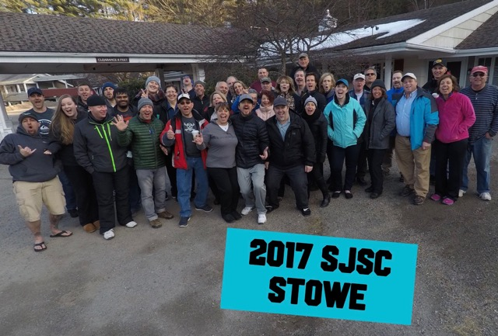
Wow, what a trip…we had it all – slush, rain, snow, sun, warm, cold. Mother Nature delivered. Bottom line, conditions were “sneaky good”, and it was a good time for all. As opposed to creating a short story, we have highlighted snippets of events that once you add them all up = equals another South Jersey Ski Club fun, memorable, ski trip.
- We had 12 New Members join us for their first trip with SJSC…wonderful to see new faces joining our club.
- The day of departure…Sunny and 73 like Hawaii, so.... each member was greeted with some colorful beads with a warm welcome of “A STOWE HA".
- The bus driver got sick and had to pull over multiple times to say hi to “RALPH.” Thankfully, one of our new members, Louie, came to the rescue! With quick action, nerves of steel, and a CDL license, he brought us safely to our hotel and drove it like it was his bus….!!!!!
- We were met by Vince from Banchi and each headed into lobby to collect our room keys and lift tickets and at 3:12 am finally jumped in bed. Can you say commitment to the ski cause!
- Day 1 was a mix of Mashed potatoes; hey it was not bad, however most of us prefer mashed potatoes on our plate. No Rain all day long - until after dinner when the sky opened up.
- On Saturday, 26 of us meet at 1:00 pm and rode the lift up on Spruce Peak side and Jason caught us on his GoPro for our afternoon decent, setting up the mood for fun, fun, fun!! It was super cool to see everyone skiing together.
- Unfortunately, we had one member with an injury but she persevered and made it back to the mountain to hang out by the fireplace.
- Buffet dinner was ok and a few of us headed out for a fun night of dancing and laughing!
- Sunday temps dropped and we awoke to some fresh POW with icier conditions; we will take it - NO RAIN, however the winds were a bit wicked and few snow devils were seen spinning around the mountain.
- We gathered for group photo and picked up our boxed lunches!! We had a fun ride home with a gifty grab bag game and a ski trivia test with a prize for the winner - Tony Mrak way to go!!
- We watched a funny oldie-but-goodie movie arriving at Ramblewood before midnight!!
- We hope you all had as much fun as we did and hope you join multiple trips next year.
- Check out the photo album here –
  - https://photos.google.com/share/AF1QipOOUu0ncj9w5kT6WF8PnPwpR_B9-DKCSRB2s_NLe0m3SndiqYDrsuzHxQgB8F56Iw?key=dTl2ZFpoQ1lxUXJoaFUxX2ZyTWVOdU9QSUdTSmdn
  - Please join, and then add your photos to the collection.
- Be sure to join the Avalanche newsletter so you can stay up to date on events and when next season opens. You can sign up here:
  - http://www.sjskiclub.com/newsletters.html
- And last, but not least, if you are on Facebook, be sure to like us – South Jersey Ski Club. We posted a couple short videos for your entertainment.
Dream in Powder,
Michelle Johnson and Jason Taitano

