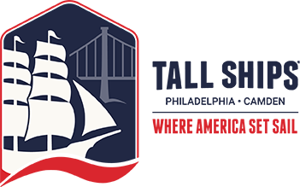

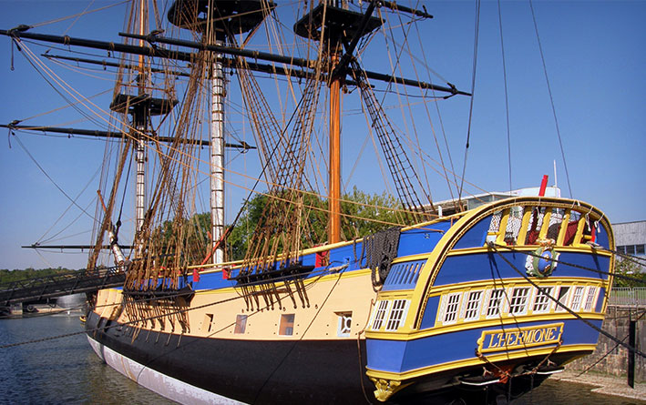
With over a dozen magnificent domestic and international ships planning to attend Tall Ships® Philadelphia – Camden, visitors can catch a glimpse, step aboard and even set sail on some of the most meticulously crafted ships of yore. Several rare and notable ships making an appearance. An abundance of attractions will accompany the Tall Ships such as historical reenactments, live music, dance, youth sail training, a craft beer garden and the regions finest fare.
When: Saturday Jun 27, 2015 9:00 AM (ends at 5:00 PM)
Cost: $15.99-$85 (See TallShipsPhiladelphia.com for more information)
Meeting: Camden Waterfront
Host: This event needs a Volunteer – contact Paul Serdiuk at pis9@yahoo.com

