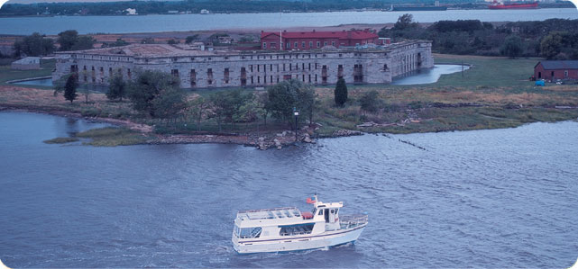
SJSC presents Three Forts Ferry Tour
Visit Fort Delaware, the Union fortress dating back to 1859, once housed Confederate prisoners of war as well as German POW’s from WWII. It was originally built to protect the ports of Wilmington and Philadelphia. Step back in time as costumed interpreters take you back to the summer of 1864. We take the ferry over to the forts. We will have lunch at Crabby Dick’s in Delaware City by the water.
Explore Delaware City, Fort Mott, Finns Point, and Fort Delaware/Pea Patch Island The Forts Ferry Crossing service on the Delaware River connects Delaware City to Pea Patch Island, home of historic Fort Delaware and the Pea Patch Island Nature Reserve, as well as Fort Mott in New Jersey. Finns Point National Cemetery is located near Fort Mott.
When: Sept 24, 2016 10:00am sharp
Where: Fort Mott parking lot.
Cost: Adults….$12.00 Seniors...$11.00 Veterans/Military.......$11.00
Fort Mott State Park 454 Fort Mott Rd Pennsville, NJ 08070
(856) 339-0467
Host: Paul Serdiuk

Reply, Reply All or Forward | More

Click to reply all

Go to the Norton AntiVirus site

Send



           



