Val Gardena/Venice 2016 – What a Great Trip it Was!!
By Bianca Mandel
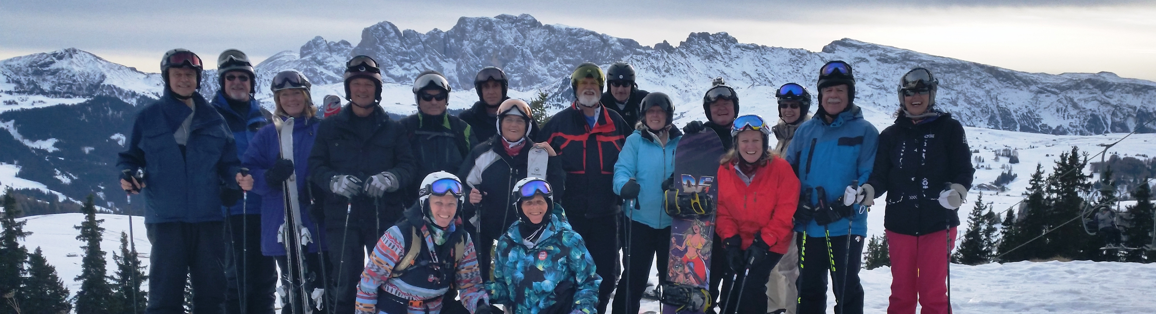
Reflecting upon this trip and beginning to write an accurate report led me to contact all of our wonderful trip participants for their feedback. The desire was to make this less of a chronological journey and more of an experiential account. Fortunately, several in the wonderful and harmonious group responded to the plea, and it is their quotes which will allow this report to truly reflect a remarkable 10 days.
We were fortunate to depart from Newark on 22 January mere hours before one of the biggest snowstorms on record hit our area. Everyone was able to breathe a sigh of relief as our plane took off into the night sky. Upon landing in Munich, we boarded our Viaggi Gardena bus driven by the affable Claudio and drove through Germany into Austria and over the Brenner Pass down to beautiful Selva, Val Gardena and the Hotel Antares. Our home away from home for 7 days was well appointed, clean as a whistle and in possession of some high quality chefs. We were certainly well fed.
“Best trip ever with SJSC: hotels, food, people weather and access to mountain tops for non-skiers. Hit 3 different ones in 4 days” – Gayle E.
Although the Dolomites had not been blessed with much natural snow, the Sud Tyrolian snowmakers and groomers proved their reputation as the best in Europe. Those who wished to were able to ski all day every day, and it was a very rare occurrence when the same slope was skied more than once during the week. One in our group, Michael Y., had not skied for over 10 years.
“I found out the hard way that certain things don’t come back naturally. I took ski school lessons for a couple of days and happily contributed to the local economy. I showed lots of progress over the week” – Michael Y.
and on our last day, Michael joined a group of friends for a beautiful day of skiing most of the trails at Plan del Gralba. He was grinning from ear to ear!
On the Dolomiti Superski circuit, one skis from valley to valley and town to town, and it was a common occurrence to cover over 20 miles of trails each day.

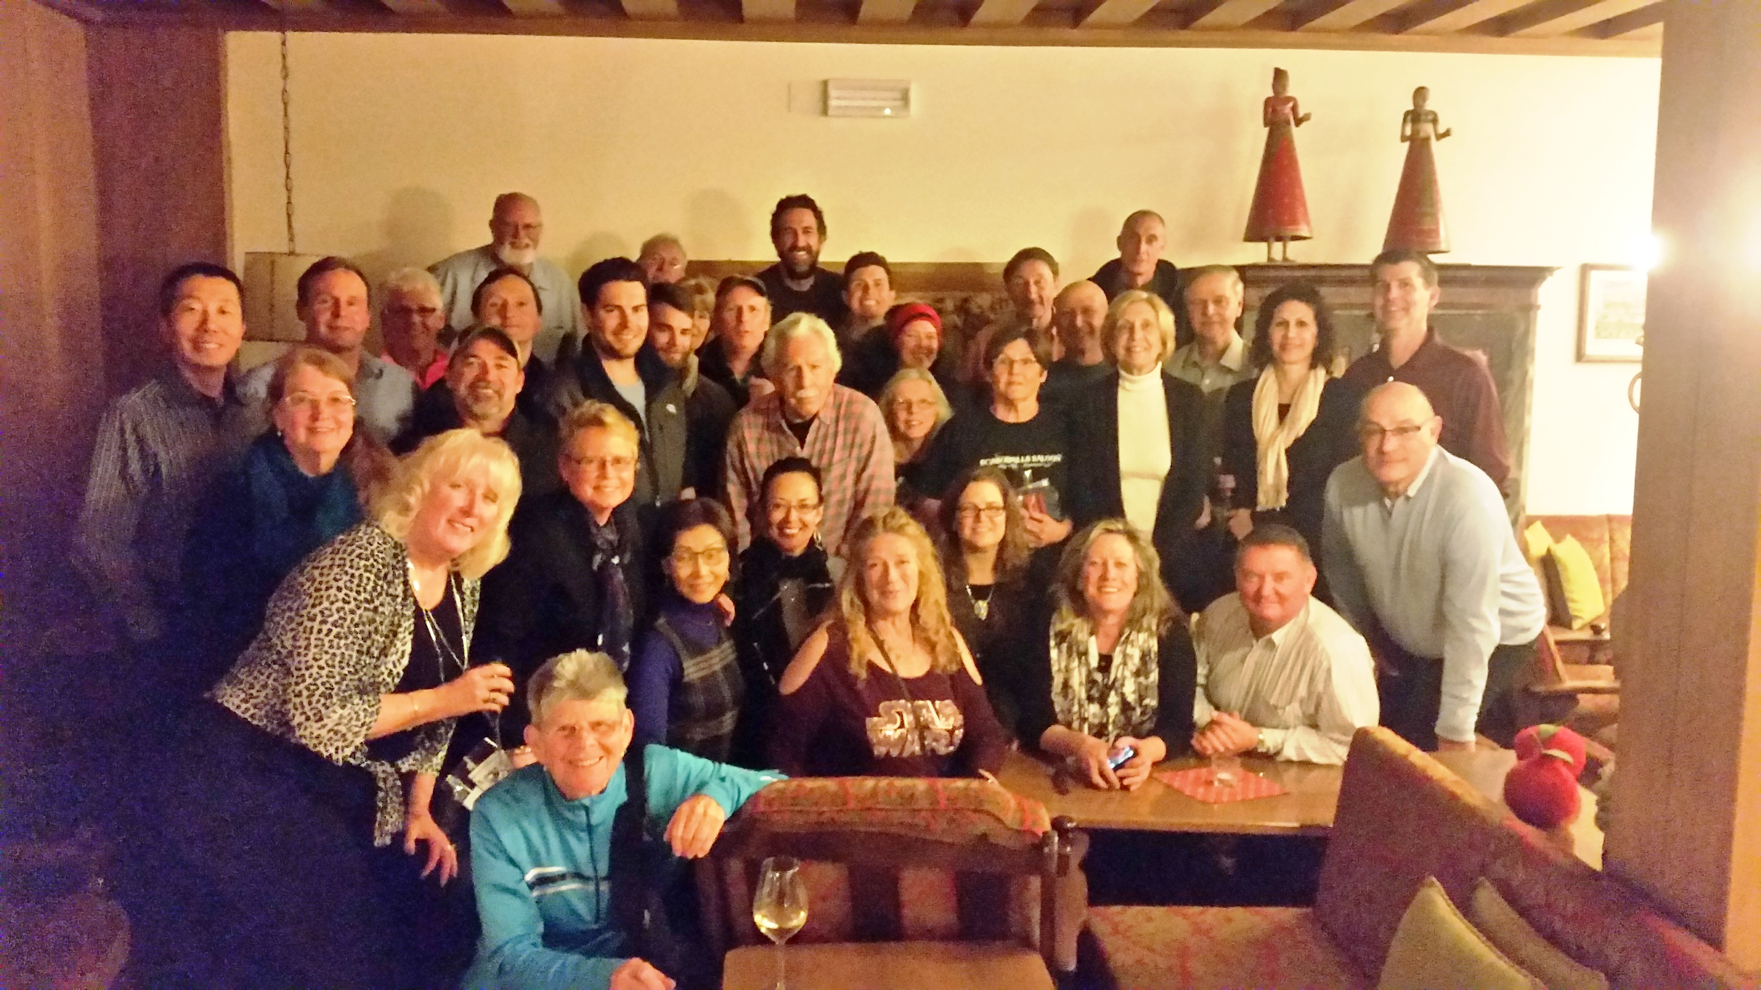
“Our leaders knowledge of the area and desire to put the needs of the group first was very much appreciated”- Bobbie S.
Large groups joined to ski the world famous Sellaronda in both the clockwise and counter clockwise directions. We were blessed with blue skies and comfortable temperatures all week, so all of the cold weather gear and hand warmers remained behind at the hotel. Skiing was an absolute pleasure, and the views from the slopes were absolutely without equal.
“Our trip leaders were so much more…they were mountain guides, translators, ski instructors and a wealth of information about every aspect of the trip! The “Group” skiing was something I was so thankful for. I would never have been able to find my way to so many great places on my own; mountain lunches were a definite highlight! And those BOMBARDINOS!” – Suzanne D.
“The trip had a life adjusting impact on me. It was unlike I ever experienced before. The culture, the people, the history and charm was very moving as well as the physical beauty. The fact that we skied for 6 days and investigated a new area each day was in itself amazing!” – Bobbie S.
“Selva was just a perfect ski town, so picturesque, great trails, delicious cafés and awesome apres ski bars!” – Ginny T.
Sadly our ski week ended at 8 AM on 30 January when we boarded Claudio’s bus, but we were all very excited about our next destination, the singular city of Venice/Venezia! As soon as our transfer by boat to the beautiful Hilton Molino Stucky was complete, no time was wasted in hurrying via hotel shuttle boat or the local Vaporetto to Piazza San Marco where the first Carnevale festivities were underway. What an exciting time it was to be in Venice with the costumes, the pageantry and an atmosphere of celebration! Our 2.5 days there passed in a blur of fun, food, frolic in mask and costume for some and
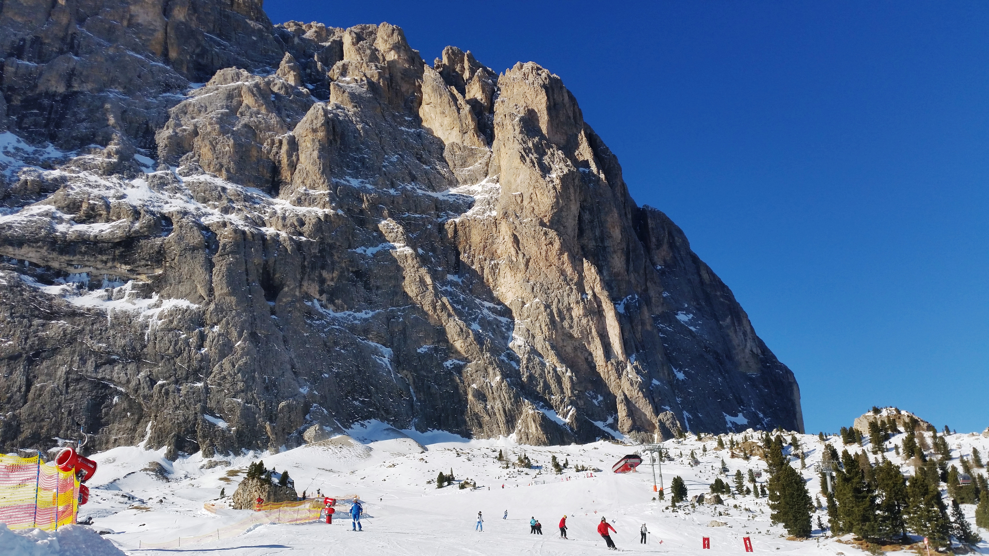
festivity. Our luck with the weather held, and neither rain nor cold marred our good time in a city that literally floats upon the water.
“Having a full size Murano glass chandelier in my Venice hotel room was the icing on the cake!” – Ginny T.
It was hard to take leave the Venetian fun and beauty, but alas the arm of reality back home was beckoning as we boarded our water boat for the airport transfer early in the morning on 2 February. Our flights from Venice to Frankfurt and Frankfurt to Newark were on time, and everyone was safely back at home by early evening. Warm goodbyes were shared by all as we straggled away from baggage claim, and it was proclaimed many times that this was the best trip ever!
Thanks to all 37 participants for being such a great group, for sharing with each other, for making new friends so easily, for being so easy to take care of and for simply being the wonderful people that you are. Bianca and Dale M., Janet D. and Mark R., Eileen M. and Joe K., Bobbie S. and Jean P., Leslie and Ed P., Michael Y. and Yan W., Steve and Chris S., Jeanne B. and Richard M., Ginny T., Nichol and Sean C., Pat R. and Devin D., John B. and Sean O., John I. and Steve H., Ronni and Jim P., Stacey S., Gayle E., Gene Z., Bill G., Tom A., Matt D., Suzanne D., Nic D’A. and Donna and Gary P. all played a part in making this trip a marvelous and memorable 10 days in time! We look forward to sharing more adventures with all of you in the future.
Grazie Mille – A Thousand Thank Yous!

