2015/2016 Co-Ed Volleyball Season
SJSC Volleyball Starts on 09/21/2015!!

We play on two courts from 6:30 – 10:00 PM at the:
DEMASI MIDDLESCHOOL
199 EVESBORO – MEDFORD RD
MARLTON, NJ 08053

The season will run on Monday Nights from 09/21/2015 to 5/23/2016, when the school is open (i.e. we don’t play on school holidays or when the school closes for weather). Games are pick up format on two courts with the goal of trying to make teams as even as possible. The level of play depends on attendance but is usually solid volleyball play for 3 hours.
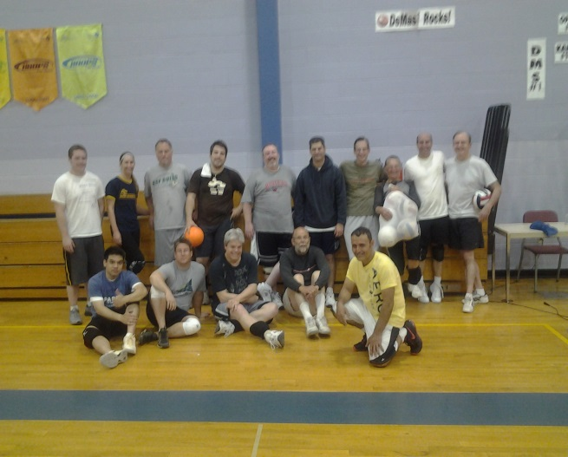To cover the cost of insurance and gym rental, the non-refundable sign-up fee for the season will be $100 per person, plus the $20 ski club membership fee. Attendance will be limited the first 24 people to sign up. In addition to volleyball and ski trips the SJSC offers many other activities/social events including:
- Fall Foliage Hikes/Camping Trips
- Happy Hours
- Softball
- Tennis
- And other social events
Contact Mark Kmiec for more info at markvolley45@gmail.com

