

**Join South Jersey Ski Club to view**

**The 66th film from Warren Miller Entertainment**

**CHASING Shadows**

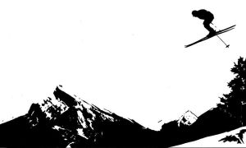

Sunday, November 22, 2015

7pm at Conestoga High School, Berwyn, PA

Group rate ticket $16

Tickets available at the ***Nov 11*** General Club meeting at Ramblewood Country Club, or by contacting Sue Jones at 609-504-3029 or [smjones310@gmail.com](mailto:smjones310@gmail.com)



Optional dinner at ***30 Main Restaurant & Bar*** <http://www.30mainberwyn.com> before the film. Anyone who’d like to carpool can meet in the parking lot at the Woodcrest PATCO station off of Rt. 295 at 4pm. Please RSVP if you plan to join us for dinner so we can reserve space.