Warwick Tavern Happy Hour
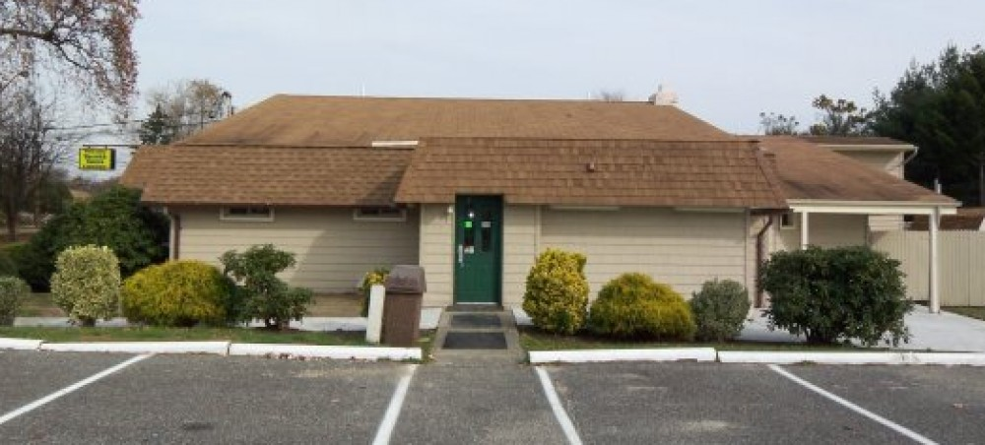
South Jersey Ski Club meets Fall Line Ski Club at the “Wick” to kick off the Ski Season
½ price wings
23oz Coors Lite $2.50
House Wines $3.50
When: December 11, 2015 5:00pm-8:00pm
Where: Warwick Tavern http://www.warwicktavern.com/
400 South Warwick Road Somerdale, NJ 08083
Host: Tammy McCoy tamskigolf@hotmail.com

