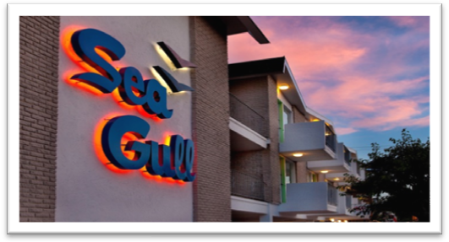
WILDWOOD SKI CLUB WEEKEND!
Sea Gull Motel hosts a weekend full of fun in the sun for
South Jersey Ski Club and Fall Line Ski Club!

Join us for a weekend at the beach, riding bikes, and many more festivities!
$175 per person double occupancy
Friday June 10 –Sunday June 12, 2015
Call 609-522-3333 or email stay@seagull-motel to book with us!!!
***included is a motel unit A (double occupancy) for 2 nights.
Check in at 3 pm and late check out of 2pm
2 breakfasts per person
Organized bike ride to Cape May
and Beer and Wine Happy Hour!
Wildwood Beer Fest takes place that weekend also: http://wildwoodbeerfest.com/
Please give us a call to make your reservation:
SEA GULL MOTEL
5305 ATLANTIC AVE
WILDWOOD NJ 08260
609-522-3333
WWW.SEAGULL-MOTEL.COM
For more information contact
Geri Benedetto 609-876-0159 for SJSC or Marge Harlow (609) 440-3897 for FLSC
geriannbenedetto@gmail.com

