ABC Summer Wines
(Anything but Chardonnay)

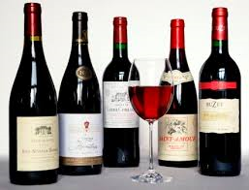

Joe Broski, wine expert extraordinaire, will be introducing us to new wines to be enjoyed for the summer or poolside, at the shore, or at that special dinner on you deck. Limited to the first 16 respondents (or waiting list). Wine, lite appetizer, dessert included.

When: Friday, May 8th, 7:00 p.m.
Where: Joe’s House in Columbus, NJ
Cost: $20.00
Contact: JoeBroski@Comcast.Net

