Lakota Wolf Preserve 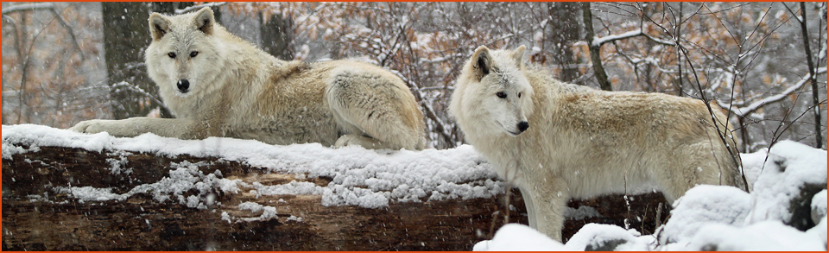

Join fellow SJSC members as we learn all there is to know about this endangered species. They offer guided educational wolf tours of the preserve called a Wolf Watch. Once again the howling of wolves echo through the mountains of the Delaware Water Gap in Knowlton Township, Warren County, NJ. Photo opportunities of a lifetime and the experience of watching and listening to packs of British Columbian, Timber, and Arctic wolves will be yours. View wolves here in the East in a natural surrounding for the first time in over a century. Bobcats and foxes also reside at the preserve.
DATE: November 22, 2015 10:00am (please allow for drive time)
ADDRESS: 89 Mount Pleasant Road, Columbia, NJ 07832 GPS Coords: 40.970933,--75.072232 We are just a few miles off Rt 80 by the Delaware Water Gap. From Rt 80 West take exit #4 (from Rt 80 East exit #4c) follow Rt 94 north for 2 miles, make a left onto Mount Pleasant Rd we are up Mount Pleasant Rd 1.5 miles on the left. Registration is in the campgrounds gift store and office.
COST: $15 for adults, cash or check only. SORRY THEY CAN NOT TAKE CREDIT CARDS
HOST: Paul Serdiuk 609-462-3593 pis9@yahoo.com ( call for carpool/ caravan info)

